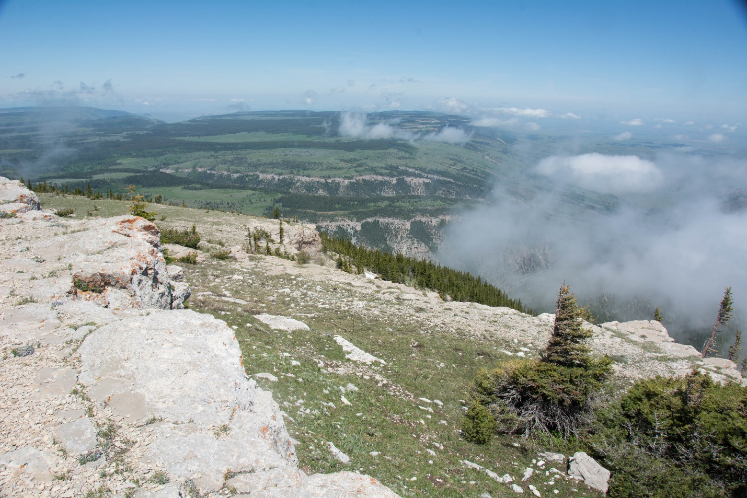
Punchbowl area, Pryor Mountains. Photo by George Wuerthner.
NAME: PRYOR MOUNTAINS—PUNCHBOWL
LOCATION: East of Bridger Montana
SIZE: 8,125 Acres
ELEVATION: Minimum Elevation 5,032 ft. Maximum Elevation 8,754 ft.
FS POLYGON 10
ATTRIBUTES The Pryor Mountains Punchbowl Proposed Wilderness is generally natural appearing consisting of steep timber covered slopes in the Punchbowl Creek drainage and north facing slopes below Dry Head Vista. Open meadow/high elevation grass at the upper elevation is found around Dry Head Vista. Sage Creek Road #2144 nearly bisects the area, coming to within less than a half mile from the northern forest boundary.
The area encompasses important cultural sites related to the use of Dryhead overlook by the Crow Tribe and also provides for a scenic overlook into the Crow Reservation and the Big Horn Canyon National Recreation Area.
Adjacent lands to the north are within the Crow Indian Reservation. Lands to the east contain private ranches used for ranching and recreation. Pryor Mountain road #2308 delineated the southern boundary and is considered a main access route within this range.
For more information see Pryor Mountains Coalition: http://www.pryormountains.org/
PLANT COMMUNITIES: Current vegetation composition is 55% Douglas fir, 20% lodgepole pine, and 15% dry grass.
WILDLIFE: Mule deer, black bear, and smaller mammals.
DRAINAGES WITHIN PROPOSAL Upper Dry Head Creek.
