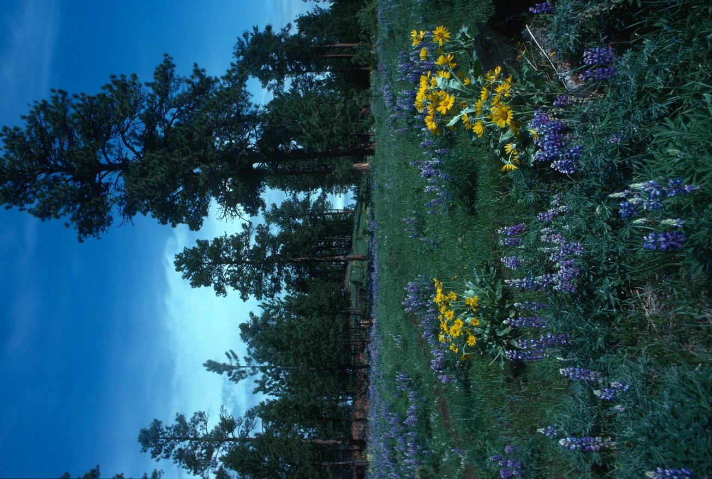

Ponderosa pine in Cook Mountain proposed Wilderness. Photo by George Wuerthner

NAME: COOK MOUNTAIN

SIZE: 12,691 acres

LOCATION: Ashland District near Birney, Montana

ELEVATIONS: Minimum Elevation 3,198 ft. Maximum Elevation 4,369 ft.

FS POLYGON NUMBER: Ashland 33

ATTRIBUTES: The Cook Mountain proposed wilderness lies just north of Cook Mountain which is not actually in the roadless area. The area is somewhat unique on the Ashland District landscape because it is largely unroaded. This area burned entirely in a 2012 wildfire which contributes to a generally natural appearance .The interior of this area is in a Semi-Primitive Non-Motorized setting and with no trails or other recreation facilities and would provide the public with opportunities for unconfined and primitive recreation.

PLANT COVER: The area is primarily northern Great Plains grassland/shrub, with 20% of the area covered with ponderosa pine.

WILDLIFE: The area supports elk, deer, and sage grouse, as well as other species typical of the northern Great Plains. There are an estimated 10,482 acres of elk security habitat.

DRAINAGES WITHIN THE PROPOSED WILDERNESS Ash Creek, Bringoff Creek-Tongue River, Colbert Coulee-Tongue River, East Fork Otter Creek, and Beaver Creek,

