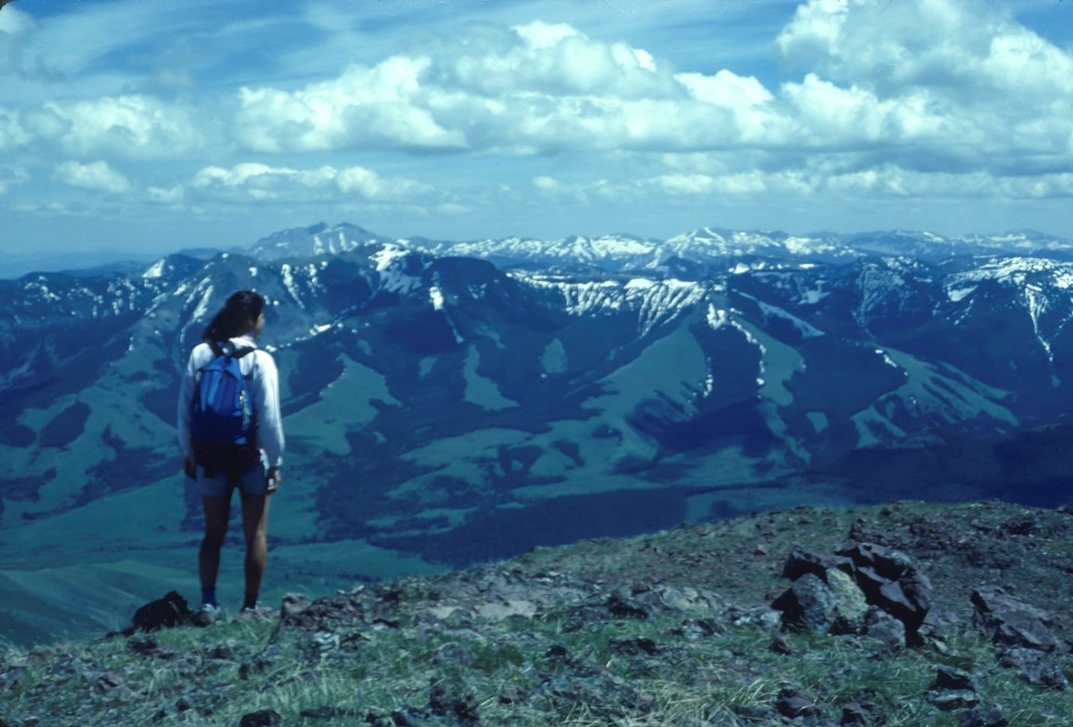
Hiker on Ramshorn Peak looking south towards Yellowstone Park. Photo by George Wuerthner
NAME: GALLATIN RANGE PROPOSED WILDERNESS
SIZE: 271,382 acres
ELEVATION: Minimum Elevation 5,048 ft. Maximum Elevation 10,335 ft.
LOCATION: South of Bozeman.
FS POLYGONS: Gallatin 2, Gallatin 24, Gallatin 28, Gallatin 31, Gallatin 55, Gallatin 56, Gallatin 62
ATTRIBUTES: The Gallatin Range Proposed Wilderness spans approximately 50 miles from the north to the Yellowstone National Park boundary on the south. The range continues south in Yellowstone National Park.
The range is highly scenic, with many of the glaciated peaks approaching 10,000 feet elevation.
The Custer Gallatin NF portion includes the 155,000 acre Hyalite Porcupine Buffalo Horn Wilderness Study Area (HPBH WSA) created in 1977 by Senate bill 393. S. 393 directs the Forest Service to manage the HPGH WSA as wilderness until such time as Congress determines otherwise.
The Gallatin Range is the largest unprotected roadless unit in the northern Greater Yellowstone Ecosystem. It contains some of the best wildlife habitat in the West, and is particularly important for grizzly bear, elk, wolves, and other larger mammals. In conjunction with the Yellowstone portion the roadless area is over 500,000 acres.
The most important portions of the Gallatin Range are those adjacent to Yellowstone including the Porcupine and Buffalohorn drainages. This area has been recognized for over 100 years for its wildlife values. Indeed, Gifford Pinchot, first chief of the US Forest Service, recommended in 1910 that the Gallatin Range be protected as a wildlife refuge. 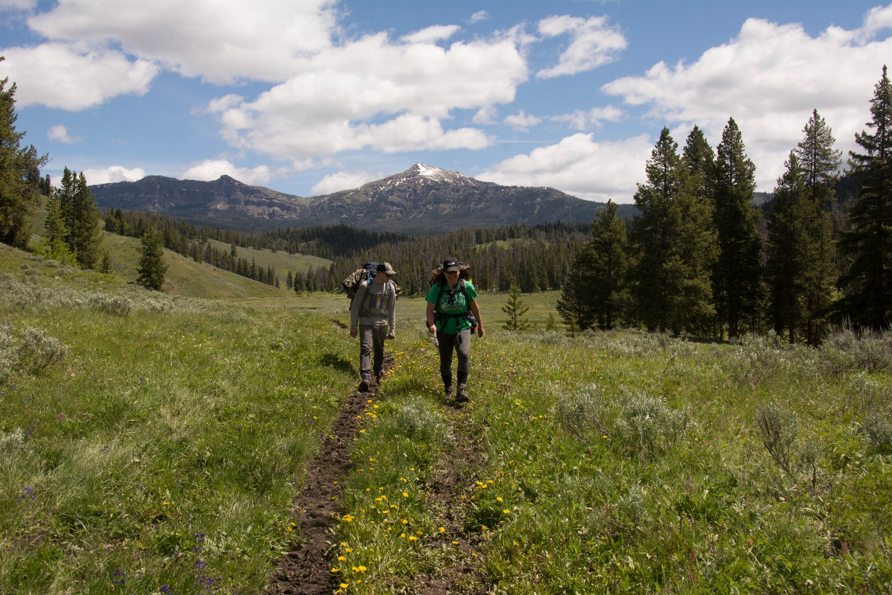
Hikers on Buffalohorn trail, Gallatin Range. Photo by George Wuerthner.
The Buffalohorn and Porcupine drainages are important migration corridor for elk moving across the Madison Range to the Madison Valley. These drainages are also used as elk winter range. These two drainages are also considered the most important grizzly bear habit outside of Yellowstone Park. The bighorn sheep in the Gallatin Range is one of the few herds that has never been genetically hybridized by transplants from other sheep herds. Wolverine and lynx have been documented here as well. The Buffalohorn-Porcupine drainages also would be excellent places for the restoration of wild bison.
The Petrified Forest near Ramshorn Peak is considered one of the finest example of this kind of fossilized forest outside of Yellowstone National Park.
The Chestnut Mountain area provides a potential connection as a migration corridor to the Bridger Range. South Cottonwood Creek is considered a “pocket wilderness” on the fringes of Bozeman.
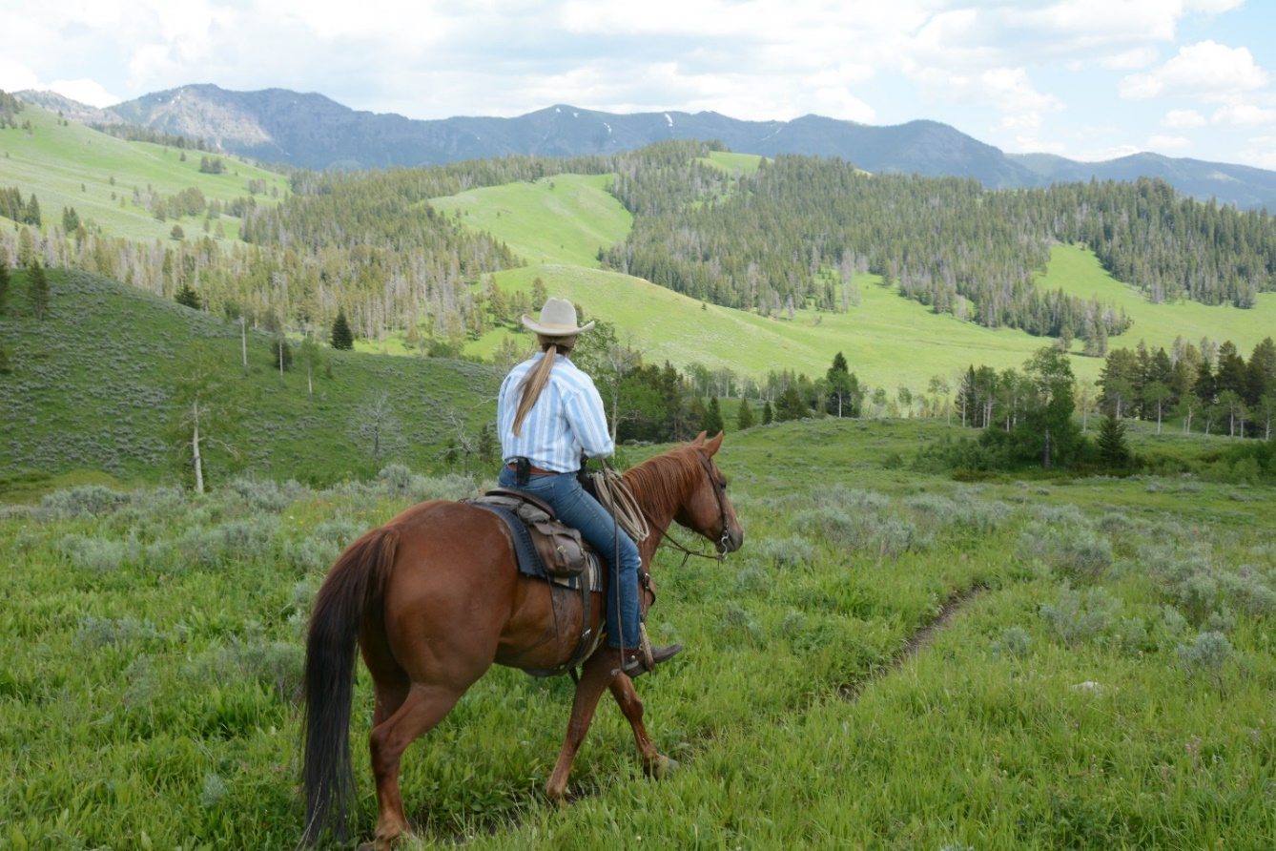 Teepee Creek part of the Buffalohorn Porcupine area adjacent to Yellowstone NP. Photo by George Wuerthner
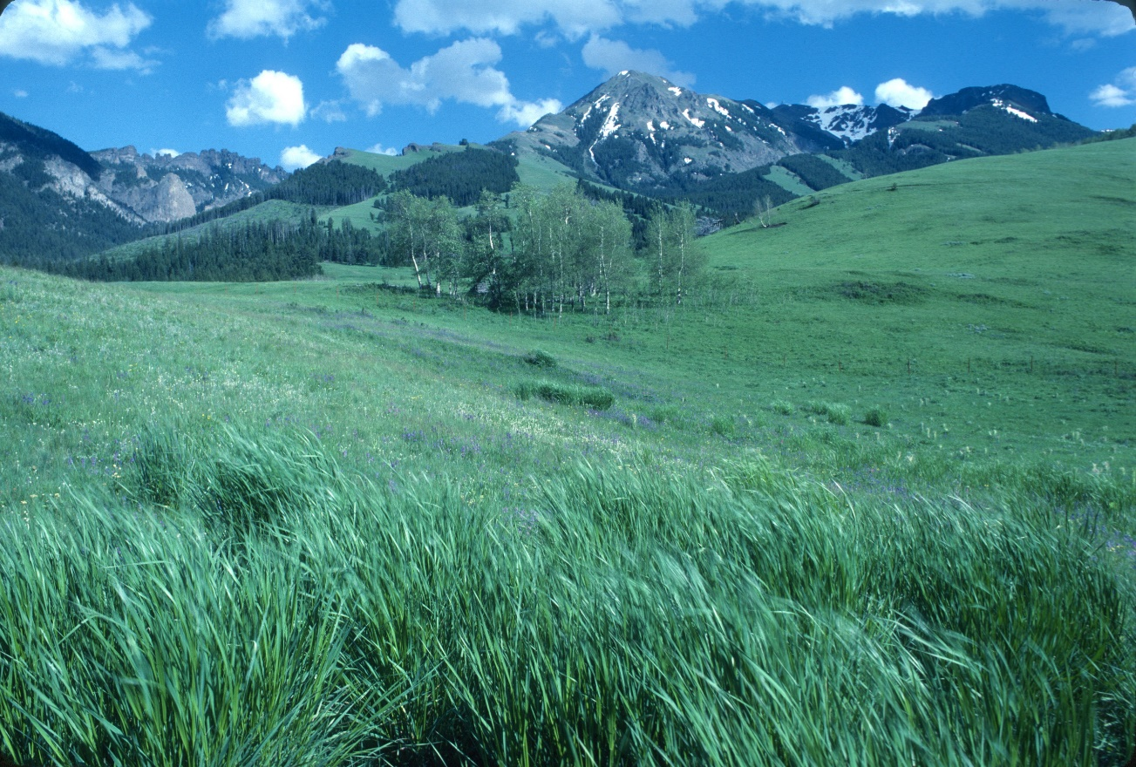
Tom Miner Basin adjacent to Yellowstone National Park. Photo by George Wuerthner

The Hyalite drainage is the most heavily visited recreation site on the Forest and includes world class ice climbing. Bozeman Creek Watershed 11,328 acres classified as a municipal watershed or community water source. Hyalite Creek Watershed 25,468 acres classified as a municipal watershed or community water source. The areas around Hyalite and Gallatin Canyon appear modified, other areas in the interior are naturally appearing.
PLANT COMMUNITIES: Douglas fir, lodgepole pine, subalpine fir, whitebark pine, Engelmann spruce, and aspen.
WILDLIFE: grizzly bear, black bear, mountain goat, bighorn sheep, wolverine, elk, mule deer, and moose. Yellowstone Cutthroat Trout known to occur within 30 miles of stream, while Westslope Cutthroat Trout known to occur within 38 miles of stream. Arctic Grayling known to occur within 3 miles of stream.
DRAINAGES IN PROPOSED WILDERNESS: Cinnabar Creek, Big Creek, Fridley Creek, Buffalohorn Creek, Porcupine Creek, South Cottonwood Creek, Upper Hyalite Creek, West Pine Creek, Upper Tom Miner Creek, Bear Creek.
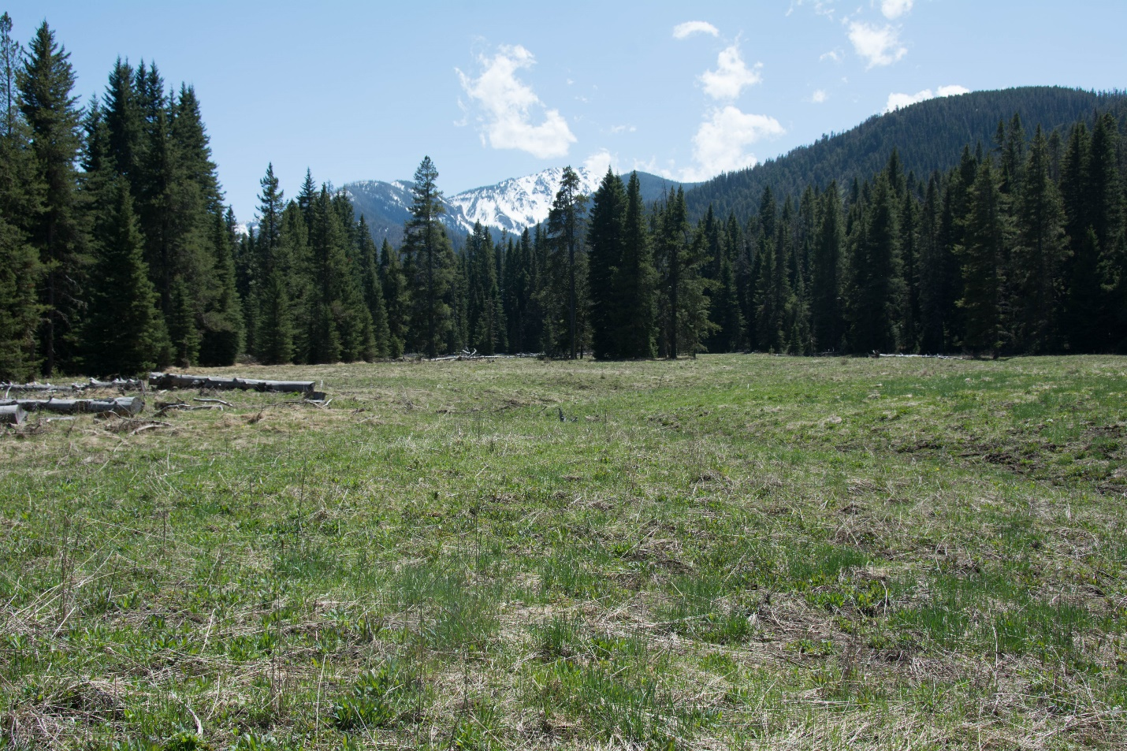
South Cottonwood Creek. Photo by George Wuerthner

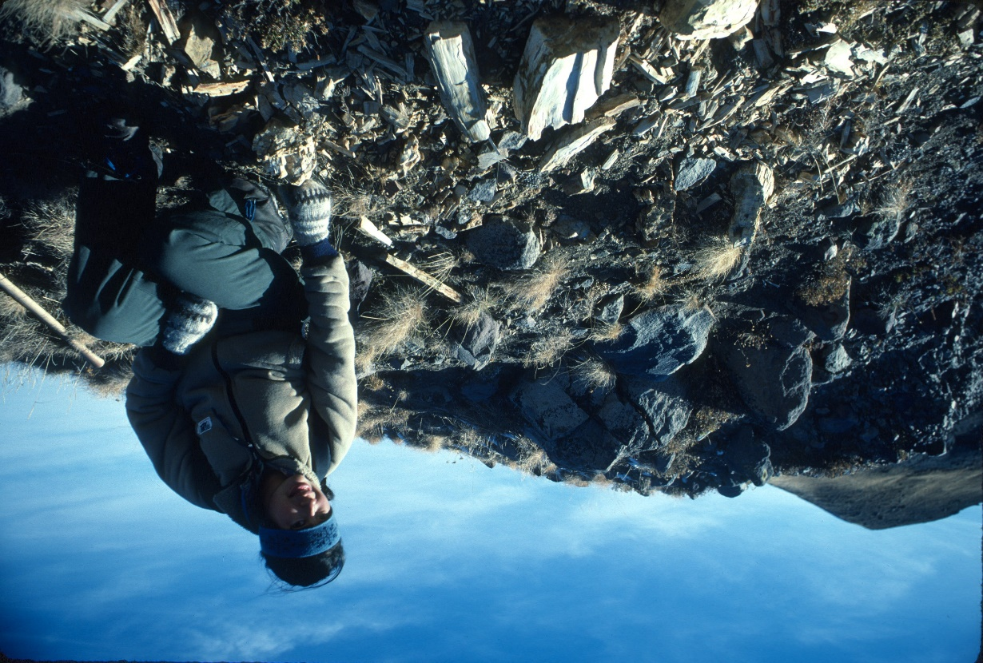
Petrified wood in the Gallatin Range. Photo by George Wuerthner

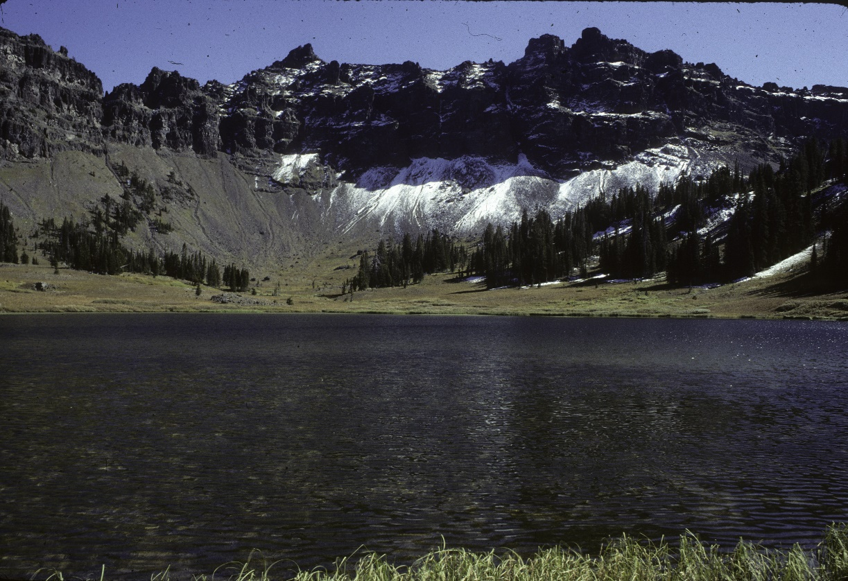
Hyalite Lake in Gallatin Range proposed Wilderness. Photo by George Wuerthner.
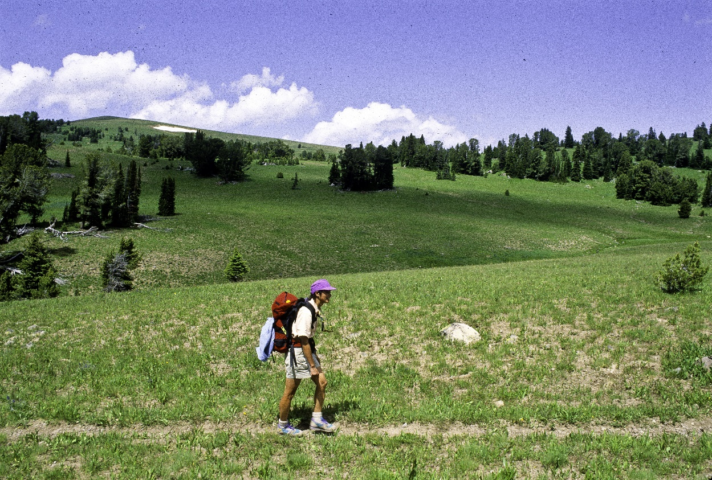
Windy Pass in Gallatin Range Proposed Wilderness. Photo by George Wuerthner
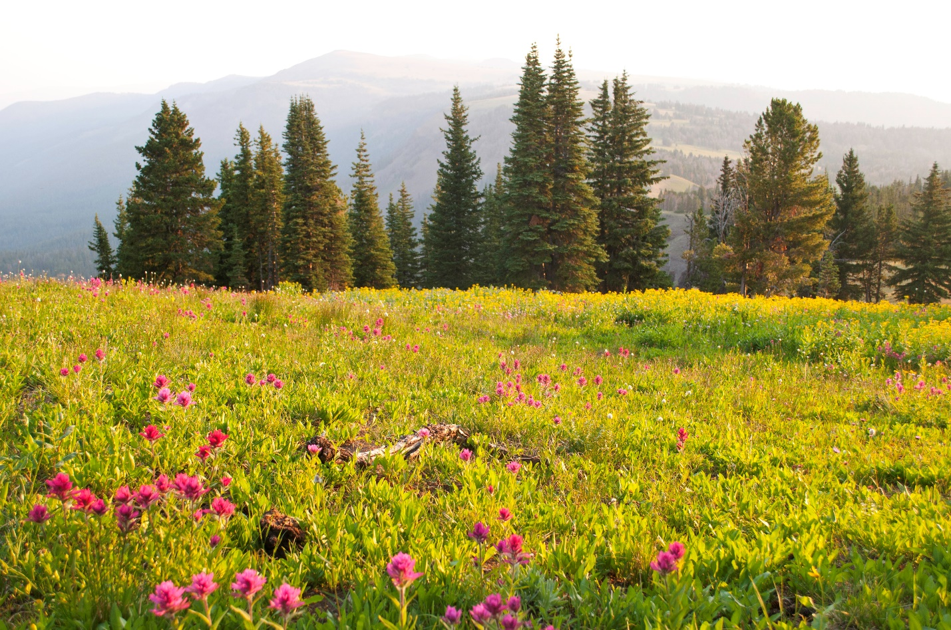
Wildflowers by Eaglenest Peak. Gallatin Range Proposed Wilderness. Photo by George Wuerthner.
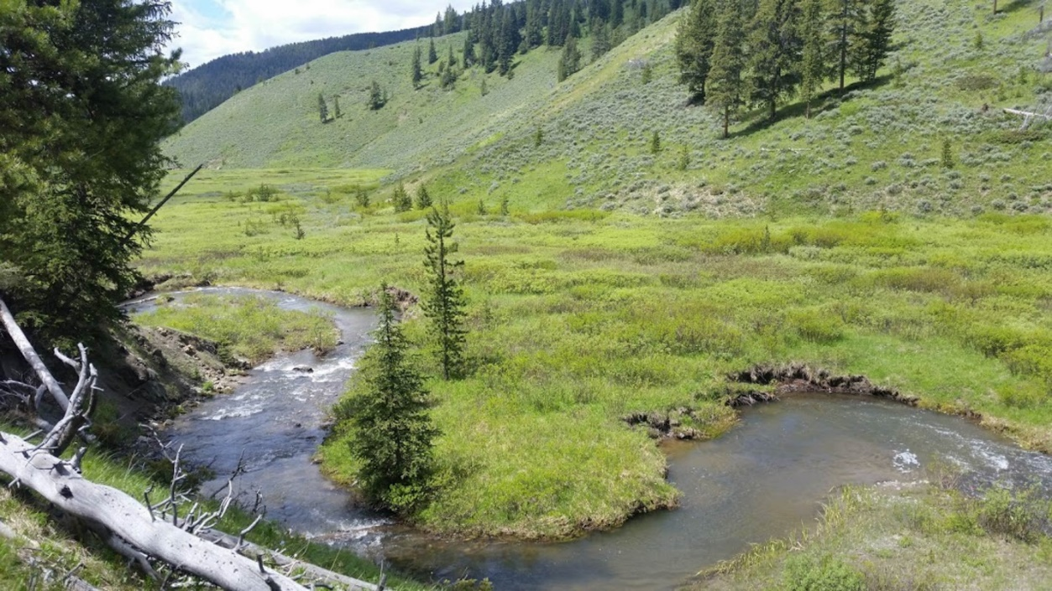
Buffalohorn Creek in proposed Gallatin Range Wilderness. Photo by George Wuerthner.
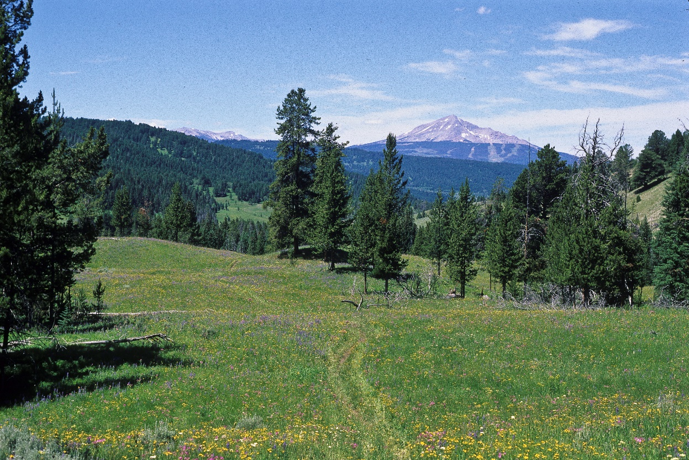
Porcupine Creek in Gallatin Range Proposed Wilderness looking to Lone Mountain in Madison Range. Photo by George Wuerthner.

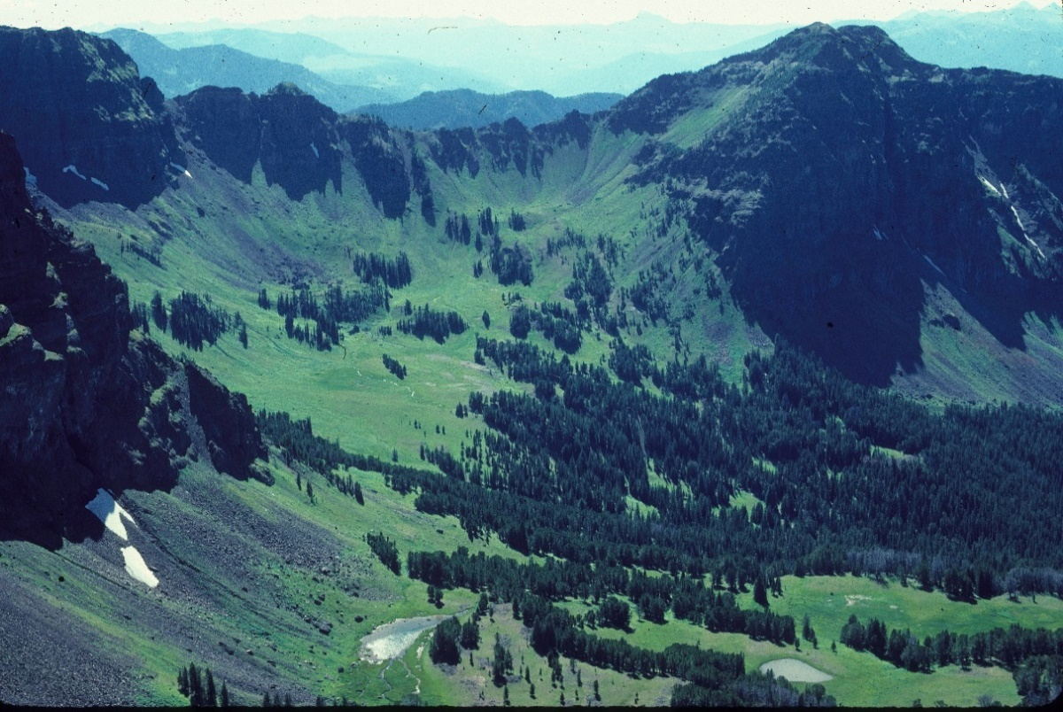
Mount Blackmore in Gallatin Range Proposed Wilderness. Photo by George Wuerthner

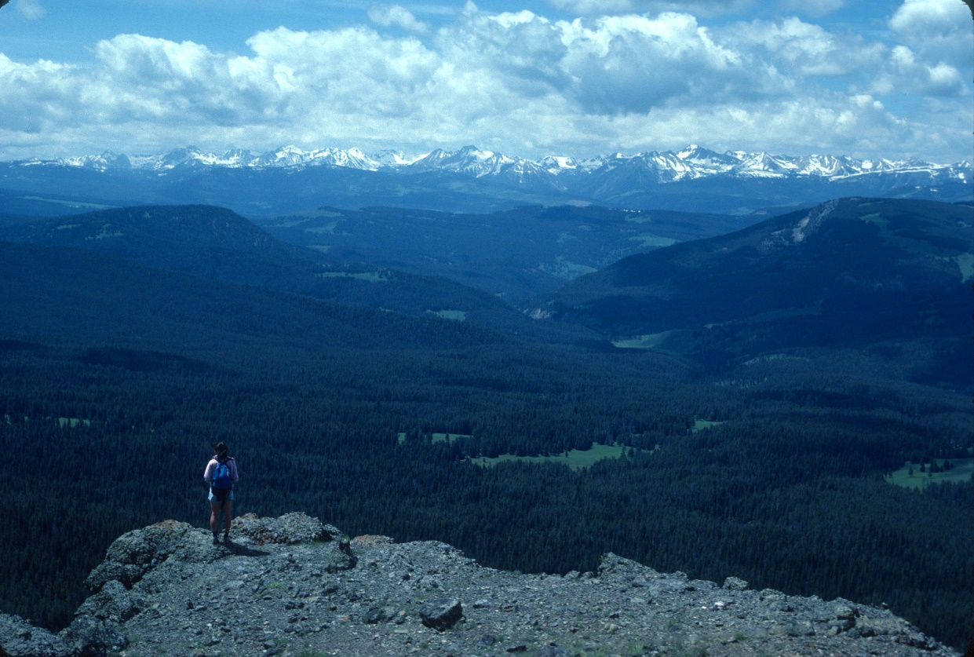
Looking down Porcupine Creek towards the Madison Range from the Gallatin Range. Photo by George Wuerthner
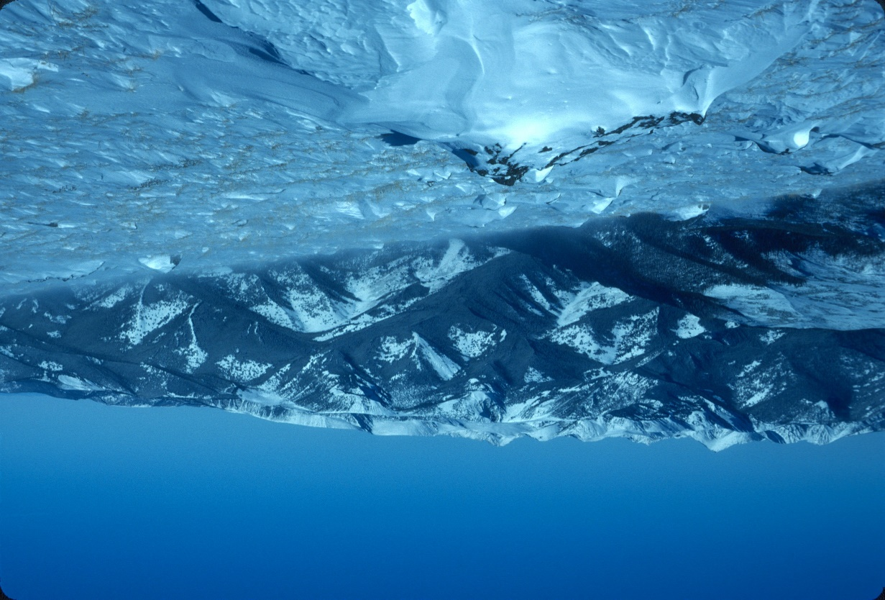
Looking from Windy Pass area in Gallatin Range towards Spanish Peaks. Photo by George Wuerthner.
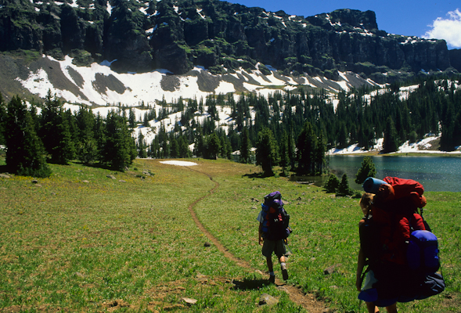
Backpackers at Emerald Lake. Photo George Wuerthner
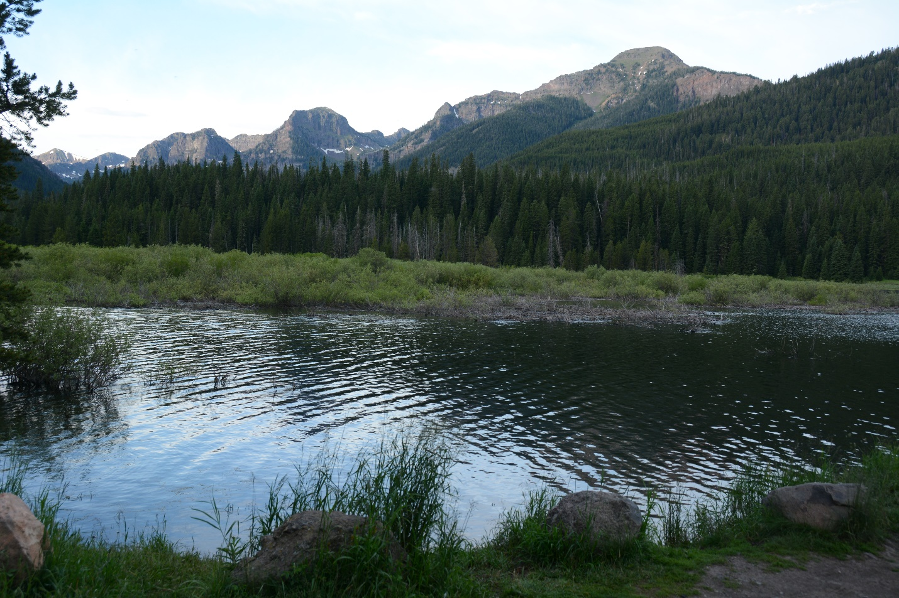 Peaks of Gallatin Range from Hyalite Canyon. Photo George Wuerthner

