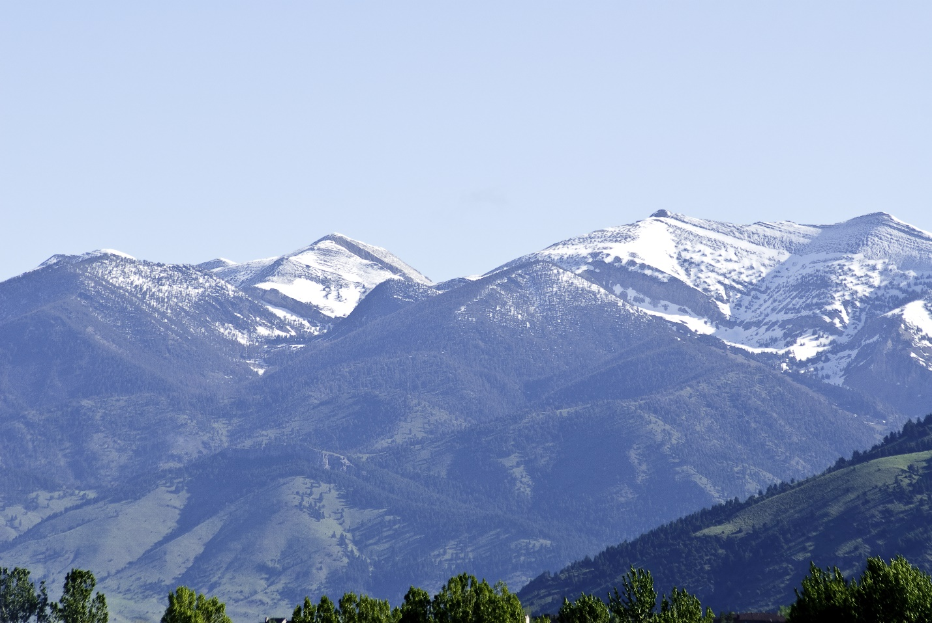
West side of Bridger Range seen from the Gallatin Valley. Photo by George Wuerthner.
NAME: BRIDGER RANGE PROPOSED WILDERNESS
SIZE: 41,500 acres
ELEVATION:
LOCATION: Northeast of Bozeman, Montana.
FS POLYGON: BRIDGERS 34
ATTRIBTUES: The Bridger Range is named for famed mountain man Jim Bridger. The proposed Wilderness includes the southern end of the Bridger Mountains. The Bridger Range is a fault block mountain range, which provides a spectacular backdrop to the Gallatin Valley. The Bridger Range is dominated by limestone and has one main rugged, glaciated ridgeline with numerous cirque basins. There are a number of creek valleys running down the flanks of the range.
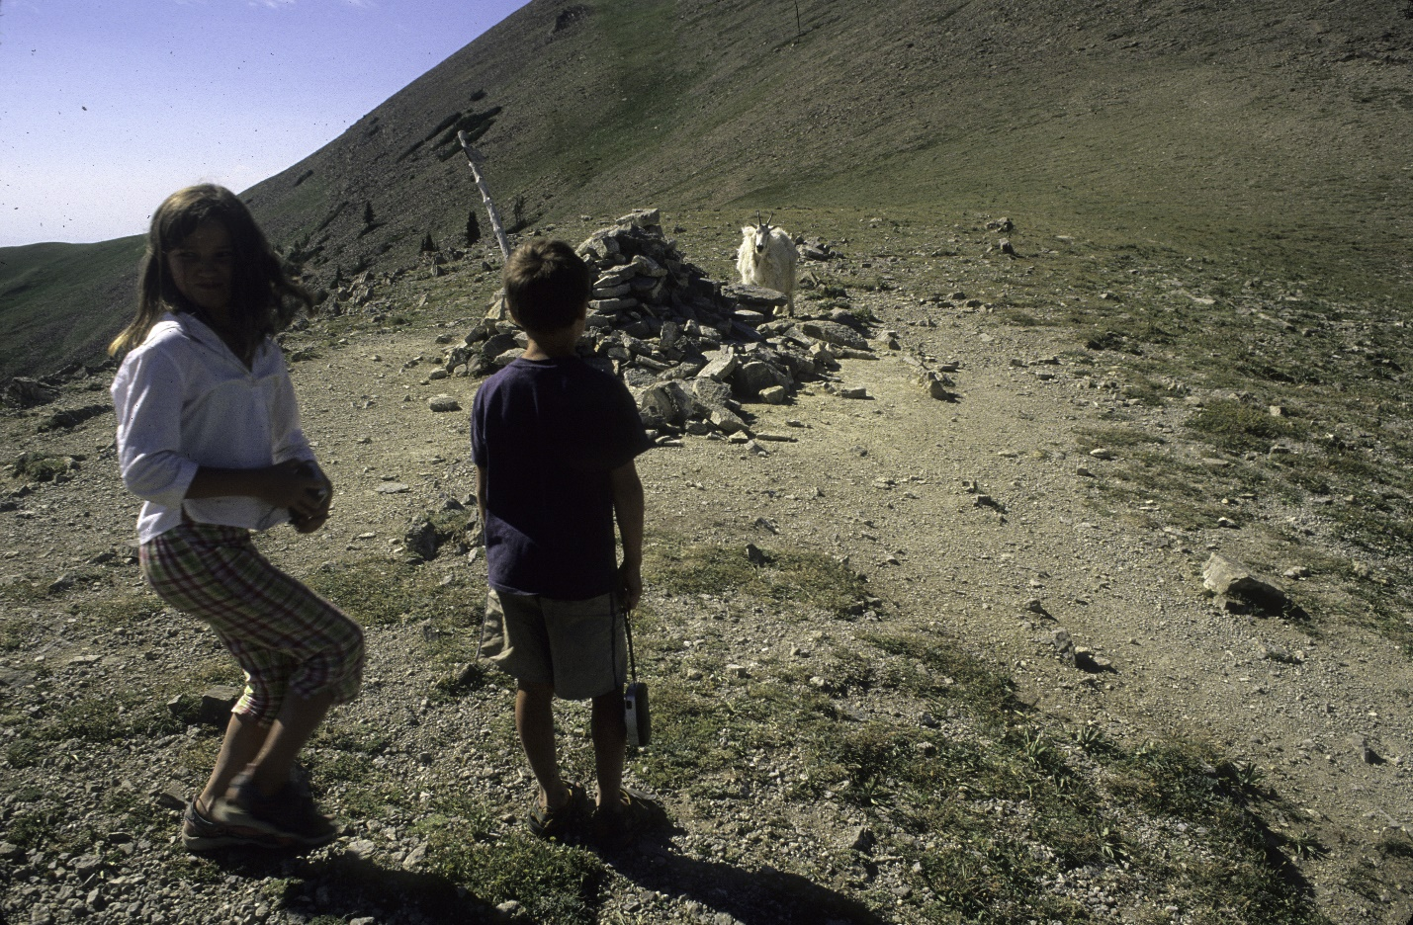
Kids encounter mountain goat near Sacajawea peak in Bridger Mountains. Photo by George Wuerthner.
The Bridger Range Proposed Wilderness is framed on the west by subdivision development of the Gallatin Valley and on the east by Bridger Bowl Ski Area. The accessibility to Bozeman makes this a prime recreational area.
The area is a major migration corridor for raptors in the fall, and also serves as a linkage to other proposed wilderness areas further north. The migration corridor split by I-90 remains relatively intact between the Chestnut Mountain area of the Gallatin Range and the southern end of the Bridger Range. Wolverine have been known to wander in the range.
PLANT COMMUNITIES:
WILDLIFE: Mountain goat, black bear, elk, mule deer, wolverine. Yellowstone Cutthroat Trout known to occur within 3 miles of stream while Westslope Cutthroat Trout known to occur within 5 miles of stream.
DRAINAGES IN THE PROPOSED WILDERNESS: Middle Cottonwood Creek, Upper Brackett Creek, Upper Bridger Creek, Upper Sixteenmile Creek, Ross Creek.
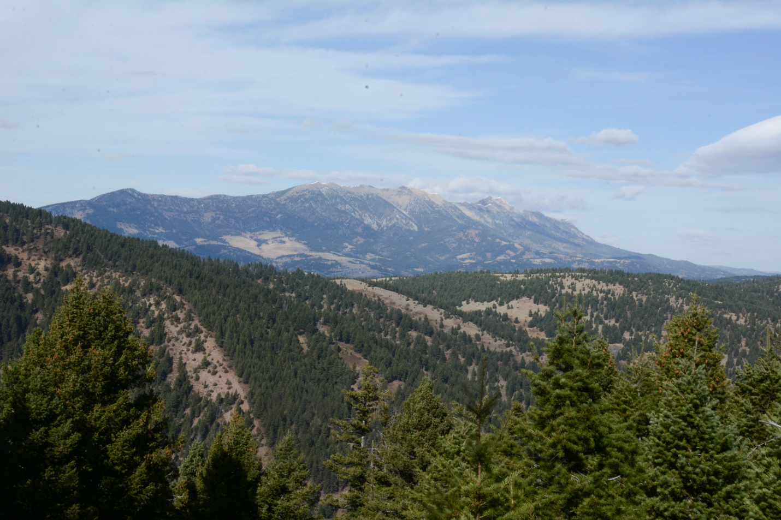
Bridger Range from Chestnut Mountain in Gallatin Range showing natural corridor. Photo by George Wuerthner.
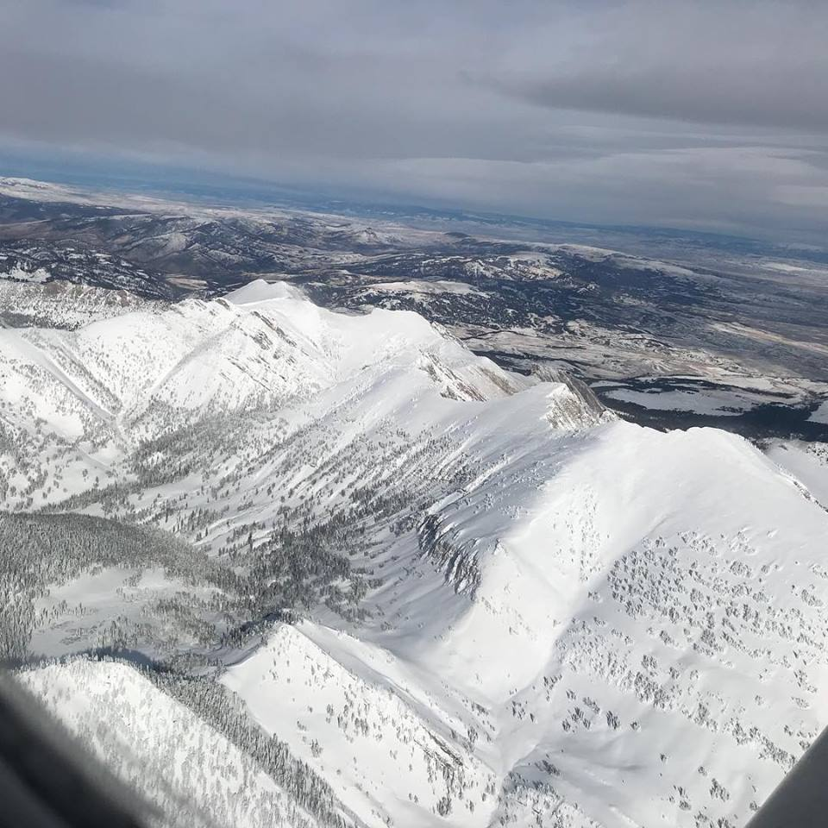
Air view of Bridger Range by Phil Knight.

