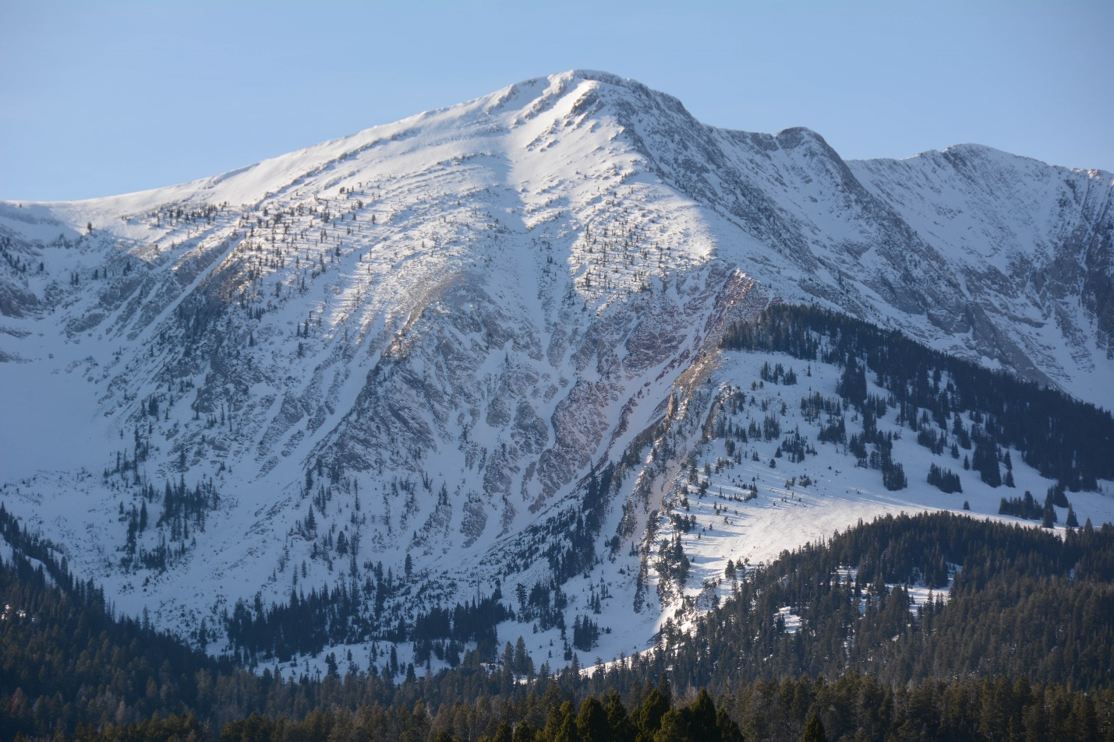NAME: NORTHERN BRIDGER RANGE PROPOSED WILDERNESS
SIZE: 12,453
ELEVATION: Minimum Elevation 5,281 ft. Maximum Elevation 8,403 ft.
LOCATION: West of Clyde Park and northeast of Bozeman, Montana.
FS POLYGON: BRIDGERS_35
ATTRIBUTES: The Bridger Range is named for famed mountain guide and trapper, Jim Bridger. The proposed Northern Bridger Range Wilderness is the northern extension of the Bridger Range. It possesses lower-elevation foothills culminating in summits like Horsethief Mountain and Blacktail Peak. The area contains elk habitat making it a popular hunting area in the fall. The Bridger Range is a natural migration corridor for wildlife between the Greater Yellowstone Ecosystem and Central Montana mountain ranges like the Big Belts.
PLANT COMMUNITIES: 70% Douglas fir, 20% dry grass, and 5% subalpine fir.
WILDLIFE: Elk, mule deer, mountain goat, black bear, and wolverine. Westslope Cutthroat Trout known to occur within 6 miles of stream.
DRAINAGES IN PROPOSED WILDERNESS: South Fork Sixteenmile Creek, Pass Creek,
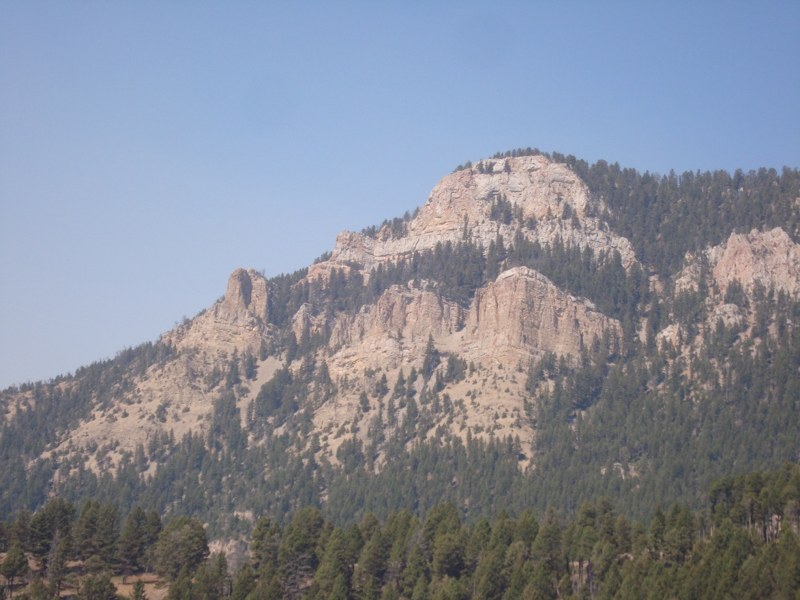
Blacktail Peak Northern Bridger Proposed Wilderness. Photo by Phil Knight.
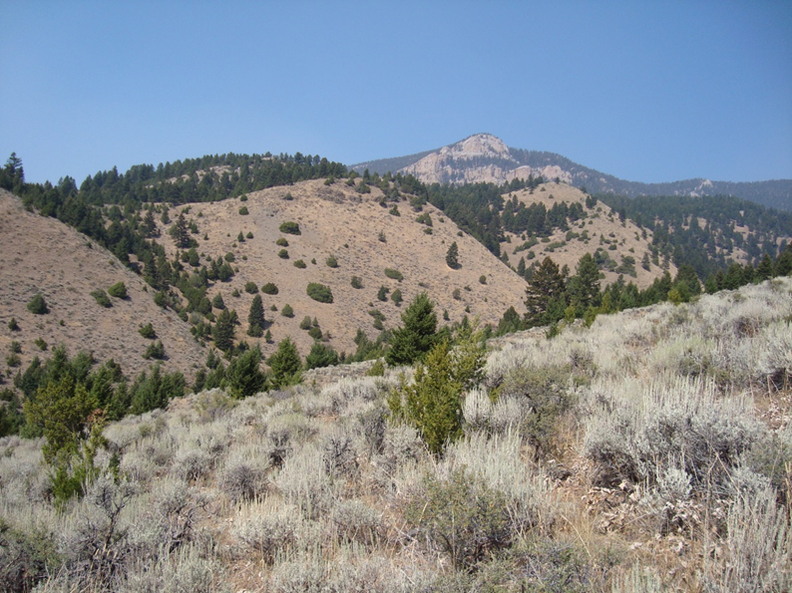
Blacktail Peak Northern Bridger Proposed Wilderness. Photo by Phil Knight.

