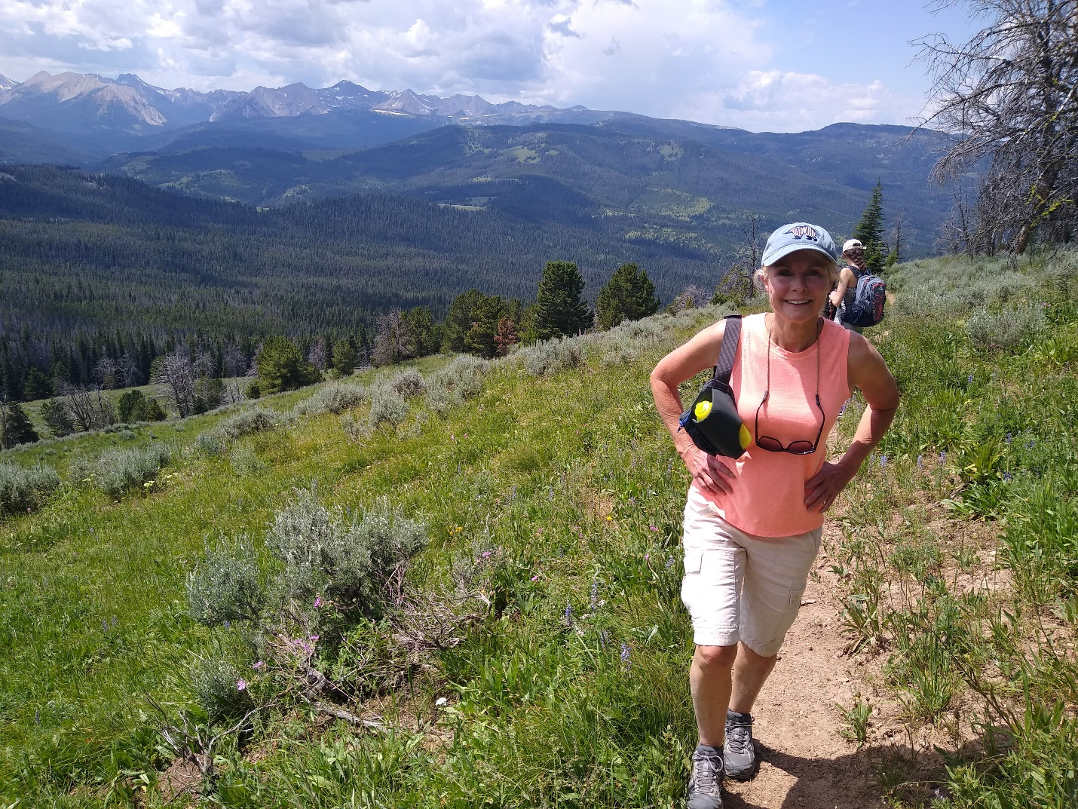
Hikers approach Cinnamon Lookout in Buck Ridge proposed addition to Lee Metcalf wilderness. Photo by George Wuerthner.
NAME: BUCK RIDGE PROPOSED ADDITION TO LEE METCALF WILDERNESS
SIZE: 42,646 acres
ELEVATION: Minimum Elevation 6,235 ft. Maximum Elevation 10,745 ft.
FS POLYGON: Madison 13
ATTRIBUTES: The Buck Ridge addition to the Lee Metcalf Wilderness is bordered by the town of Big Sky to the north, designated wilderness to the west, and the Taylor Fork recreation corridor to the south. It is generally open forest and meadows with some small lakes. It includes Buck Creek, Elkhorn Creek and South Fork West Fork Gallatin River. There are lot of ATVs and mountain bikes in this area. This area was supposed to be in the Lee Metcalf Wilderness but was yanked at the last minute by John Melcher. Buck Ridge is a very popular ATV route in the summer and snowmobile area in the winter.
PLANT COMMUNITIES: 20% Engelmann spruce, 15% Douglas fir, 15% shrub land, 15% dry grass, 10% whitebark pine, 10% subalpine fir, and 5% lodgepole pine.
WILDLIFE: Grizzly bear, black bear, elk, mule deer, and moose. Westslope Cutthroat Trout known to occur within 26 miles of stream.
DRAINAGES IN PROPOSED WILERNESS: Taylor Creek, Buck Creek, Beaver Creek.

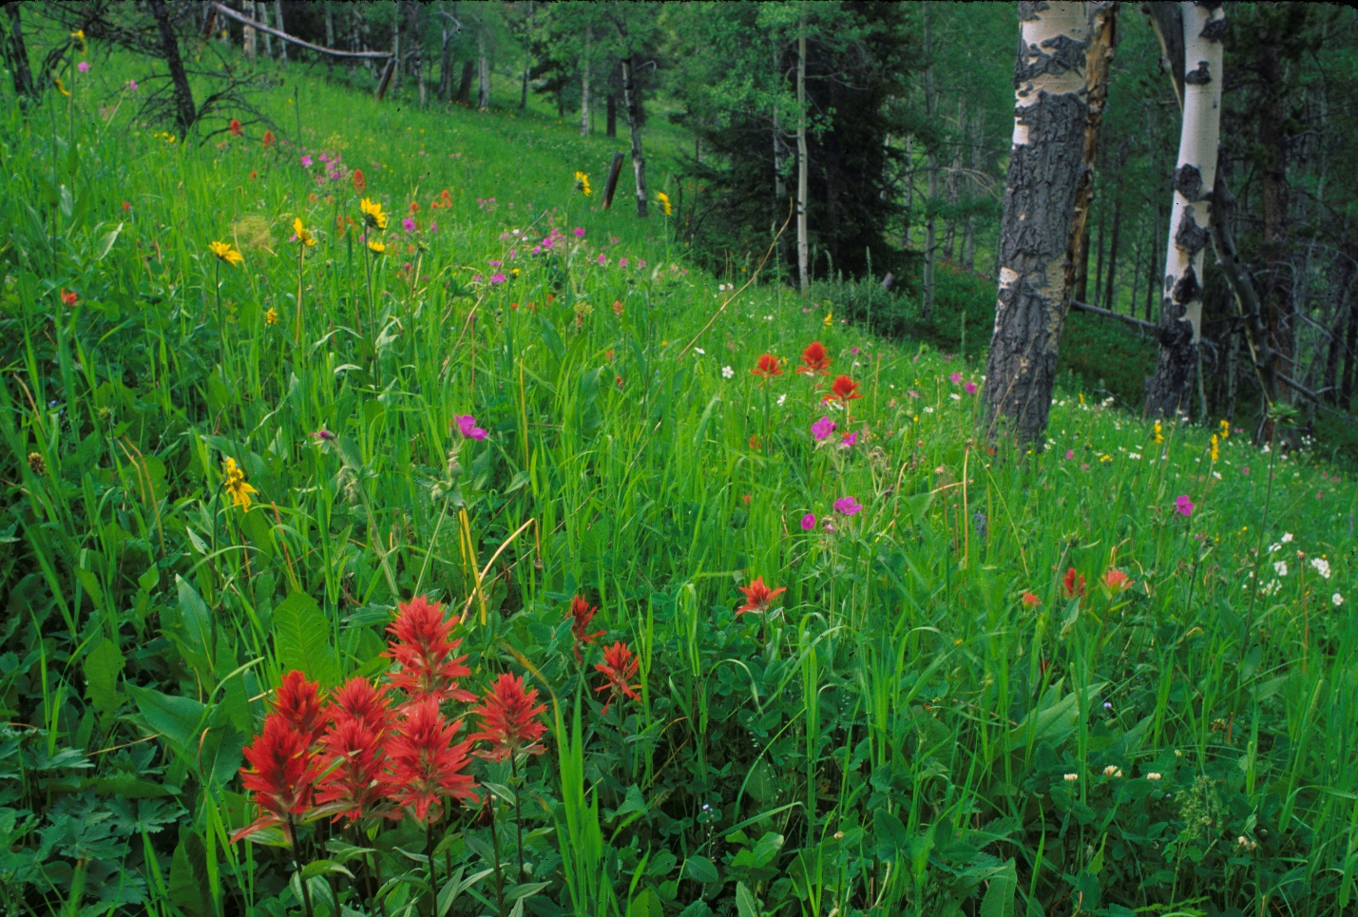
Paintbrush and aspen. Buck Ridge Proposed addition to Lee Metcalf Wilderness. Photo by George Wuerthner.

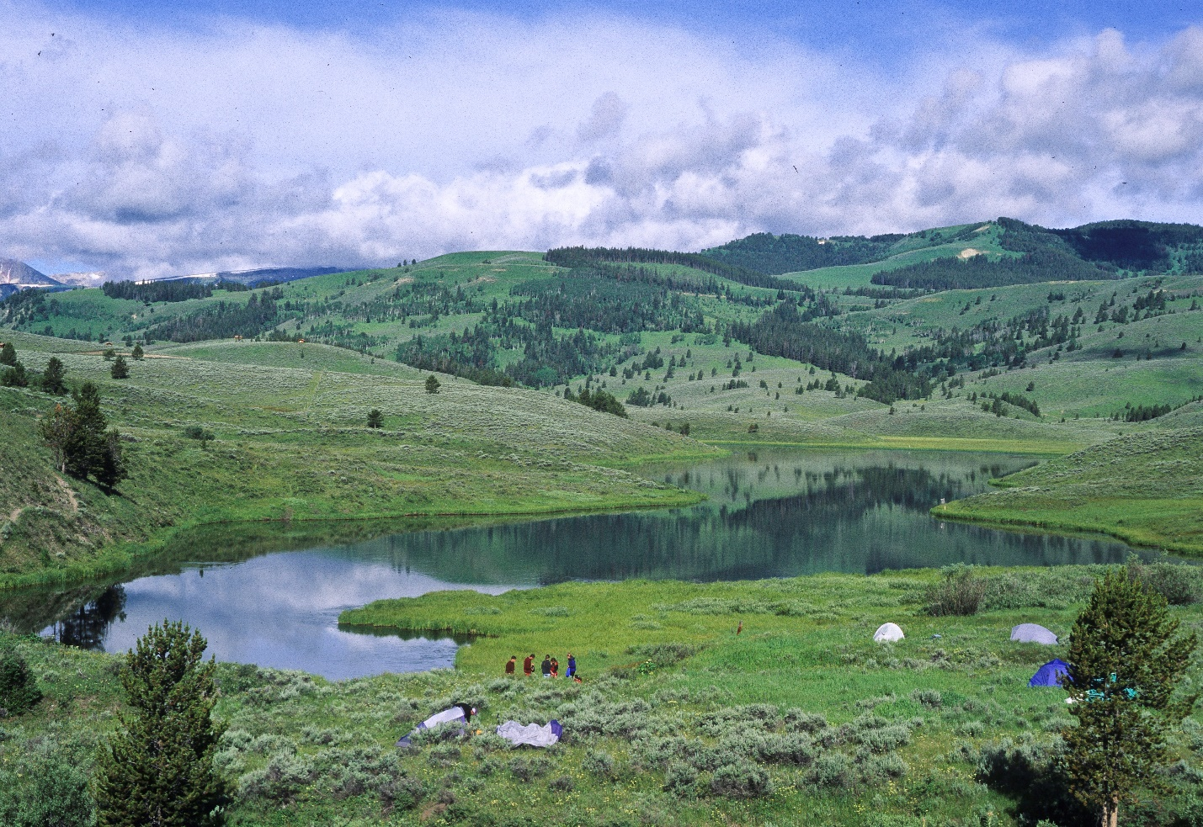
Albino Lake in Buck Lake proposed addition to Lee Metcalf Wilderness. Photo by George Wuerthner.

