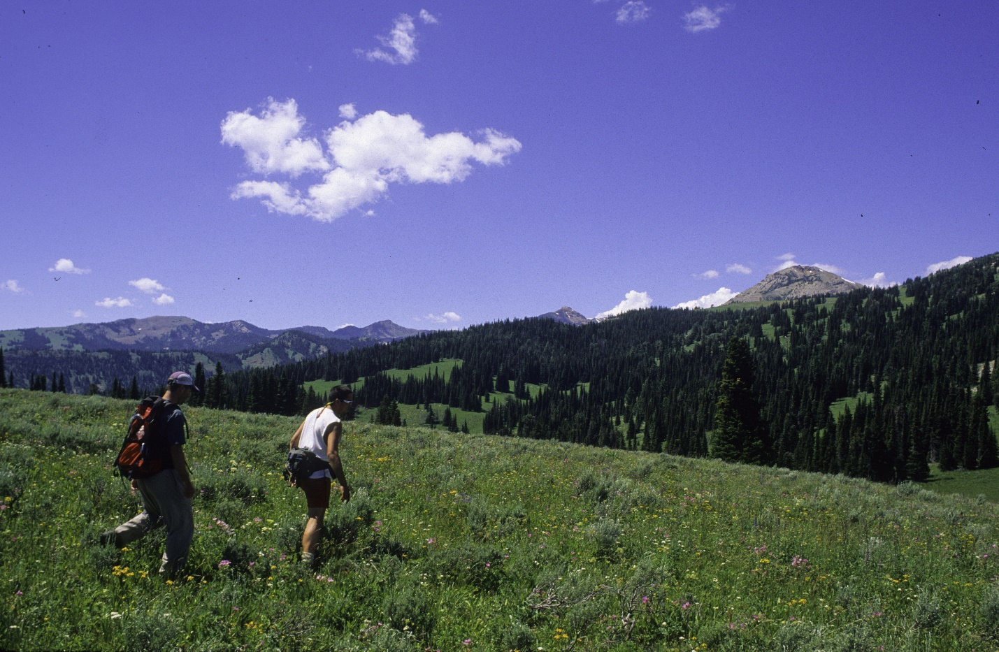
Hikers on the Continental Divide below Lionhead Peak. Photo by George Wuerthner.
NAME: LIONHEAD PROPOSED WILDERNESS
SIZE: 43,759 acres.
ELEVATION: Minimum Elevation 6,186 ft. Maximum Elevation 10,611 ft.
LOCATION: North of Targhee Pass, west of Hebgen Lake near West Yellowstone, Montana.
FS POLYGON: Henry 39
ATTRIBUTES: The Lionhead Area is characterized by open meadows and sweeping views, along with a high diversity in ecosystem types. The low elevation eastern side is primarily lodgepole pine with some aspen, while the center of the Lionhead area has more high elevation species such as whitebark pine. Three lakes are popular fishing destinations. There are 18 miles of the Continental Divide Trail (CDT) within the Lionhead proposal. Portions of this area (22,800 acres) were previously recommended as Wilderness in the 1987 Gallatin Forest plan. This proposed wilderness lies adjacent to additional roadless lands on the Deerlodge Beaverhead NF and Targhee NF that are also proposed for wilderness, making the final size of this area much larger.
PLANT COMMUNITIES: 25% subalpine fir, 25% Douglas fir, 15% dry grass, 15% lodgepole pine, 10% Englemann spruce.
WILDLIFE: Grizzly bear, bighorn sheep, moose, elk, mule deer, and wolverine. Westslope Cutthroat Trout known to occur within 9 miles of stream.
DRAINAGES WTIHIN PROPOSED WILDERNESS: Mile Creek, Earthquake Lake.

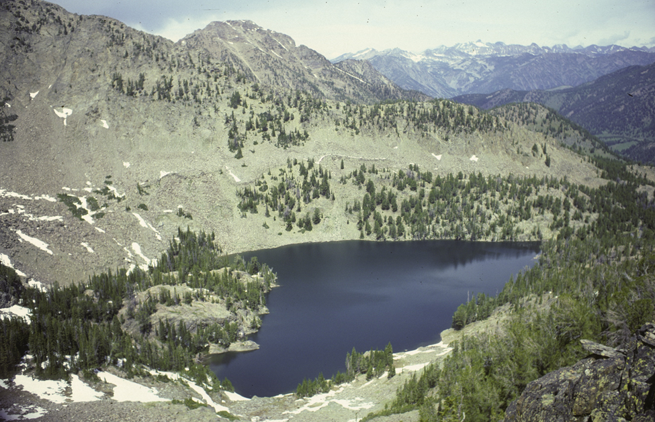

Unnamed lake in Lionhead proposed wilderness looking north to peaks in Lee Metcalf Wilderness. Photo by George Wuerthner.
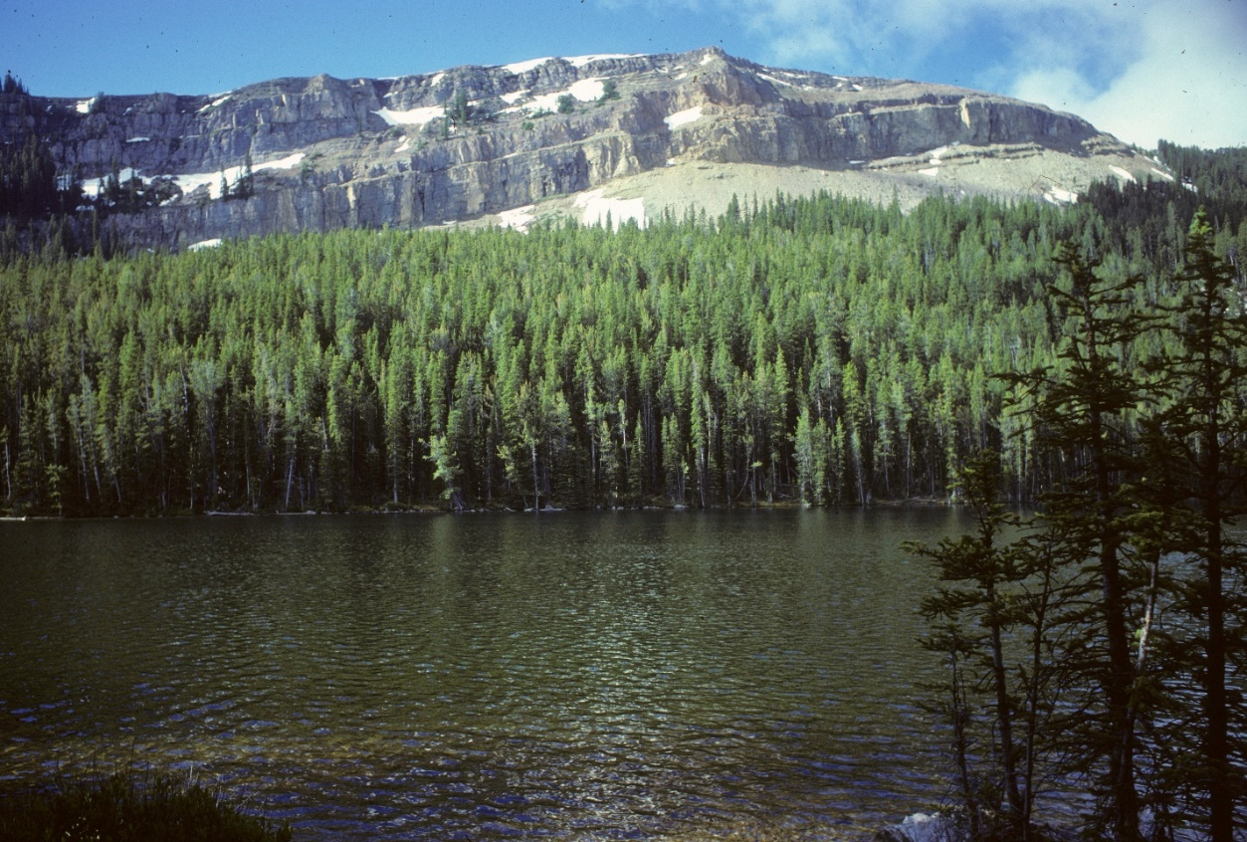
Coffin Lake in Lionhead proposed wilderness. Photo by George Wuerthner.
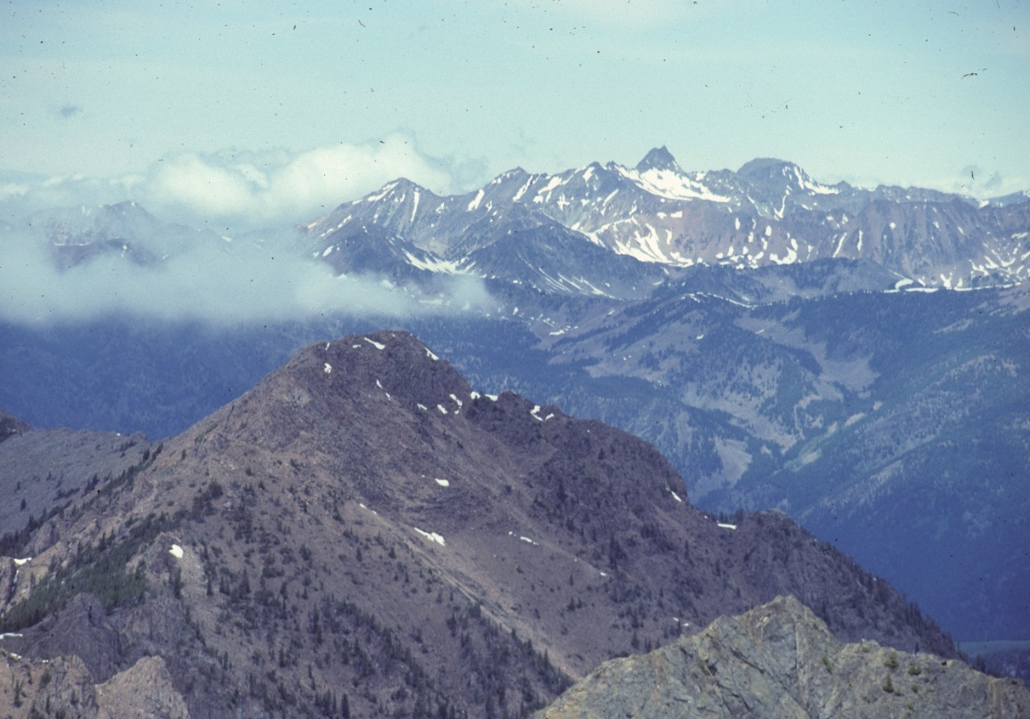
Looking towards Madison Range (Lee Metcalf Wilderness) from Lionhead Proposed Wilderness. Photo by George Wuerthner.

