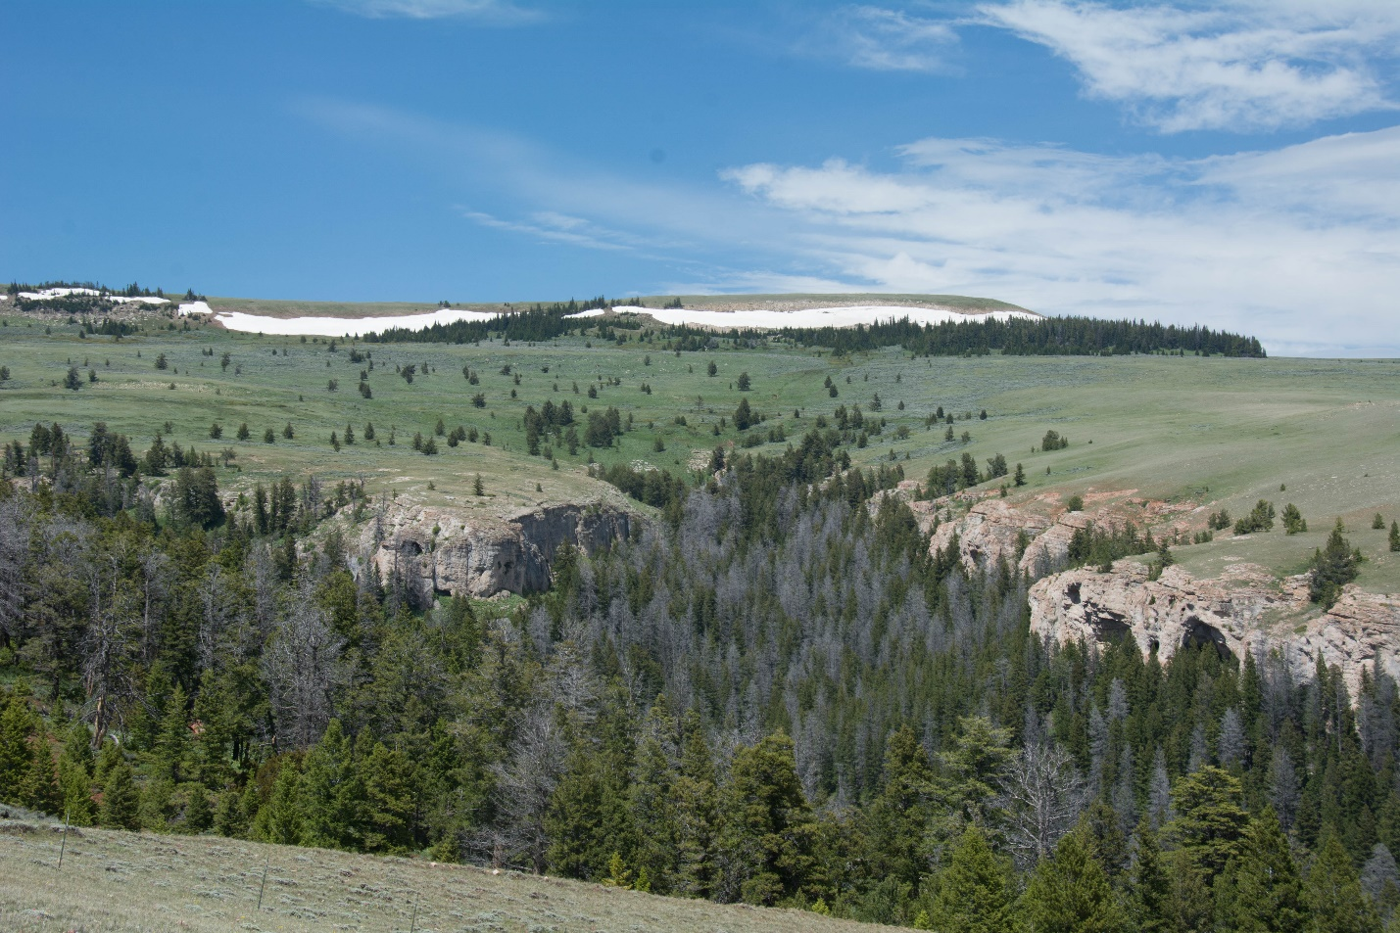
Big Pryor Mountain and headwaters of Bear Creek. Photo by George Wuerthner.
NAME: BIG PRYOR MOUNTAIN
SIZE: 12,000 acres Acres
ELEVATION: Minimum Elevation 4,997 ft. Maximum Elevation 8,783 ft.
FS POLYGON 9
LOCATION: East of Bridger, Montana
ATTRIBUTES: The Big Pryor Mountain area is generally naturally appearing consisting of open sage covered slopes at the lower elevations, timber covered slopes at mid to upper elevations and large expanses of open meadow/high elevation grass at the upper elevations. Deep rugged canyons are spread across the south side of Big Pryor/Red Pryor Mountain including Timber Canyon, Water Canyon, Inferno Canyon, King Canyon and Bear Canyon. The north side of Big Pryor Mountain consists of steep timbered slopes. Bear Canyon which is the largest canyon with three drainages in it that notably less developed and provide for non-motorized recreation.
This area contains some of the most unique and greatest variety of cultural sites in the Pryors including homesteads, wikiups, lodges, cribbed log structures, fasting locations, ice caves, and mines. Traditional cultural properties include “where they saw the rope” and where the Thunder bird nests.
For more information contact Pryor Mountains Coalition. http://www.pryormountains.org/
PLANT COMMUNITIES: Current vegetation composition is 35% dry grass, 25% lodgepole pine, 20% Douglas fir, and 10% juniper. Some 450 acres burned in 1980. 8 acres burned in 1985 and 2,874 acres burned in 2002.
WILDIFE: Black bear, mule deer, and sage grouse.
DRAINAGES WITHIN THE PROPOSAL: Bear Creek, Sage Creek, and Piney Creek.
