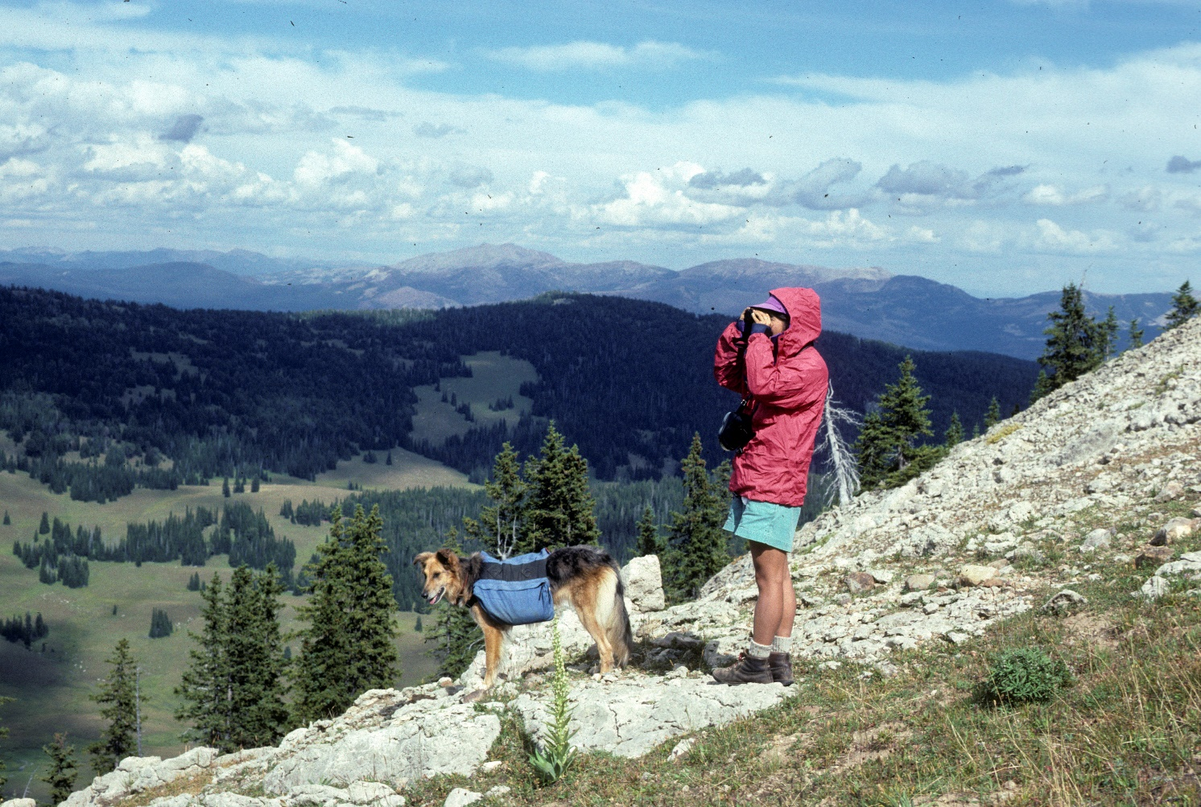
Overlooking upper Cabin Creek. Photo by George Wuerthner
NAME: CABIN CREEK ADDITION TO LEE METCALF WILDERNESS
SIZE: 111,565 acres
ELEVATION: Minimum Elevation 6,281 ft. Maximum Elevation 10,634 ft.
FS POLYGON: Madison 12
ATTRIBUTES: The Cabin Creek addition to the Lee Metcalf Wilderness is sandwiched between the Taylor Peaks and Monument Mountain units of the Lee Metcalf Wilderness and by Hebgen Lake on the south. This large area was left out of the Lee Metcalf Wilderness to accommodate mostly snowmobiles use, however, it contains many meadows and rolling terrain, thus is one of the most important wildlife areas. The area is a significant migration route for elk moving from Yellowstone to winter range in the Madison Valley. It is also one of the better places for restoration of wild bison. Some 510 acres of this area are within the Black Butte RNA which includes large, sometimes multiple-stemmed whitebark pine, dry subalpine forest Abies lasiocarpa, Pinus albicaulis, and Festuca idahoensis habitat type.
PLANT COMMUNITIES: 25% subalpine fir, 20% Englemann spruce, 15% Douglas fir, 15% dry grass, and 10% transitional forest.
WILDLIFE: Grizzly bear, black bear, moose, elk, mule deer, mountain goat. Westslope Cutthroat Trout known to occur within 54 miles of stream.
DRAINAGES IN THE PROPOSED WILDERNESS; Cabin Creek, Teepee Creek, Sage Creek, Upper and Lower Taylors Creek.
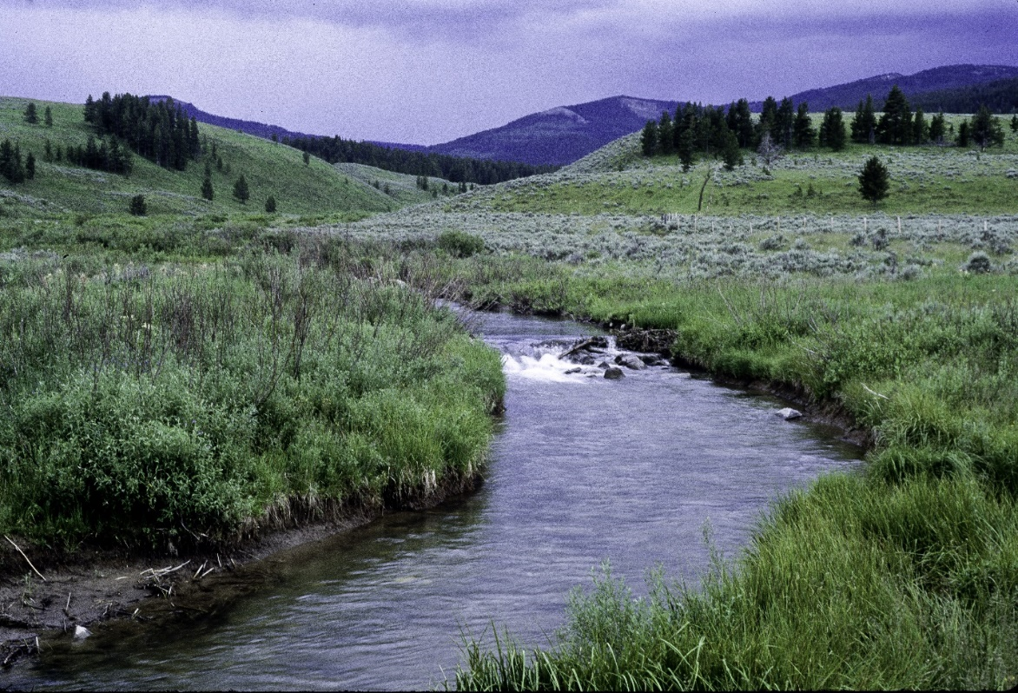
Wapiti Creek in Cabin Creek addition to Lee Metcalf Wilderness. Photo by George Wuerthner.
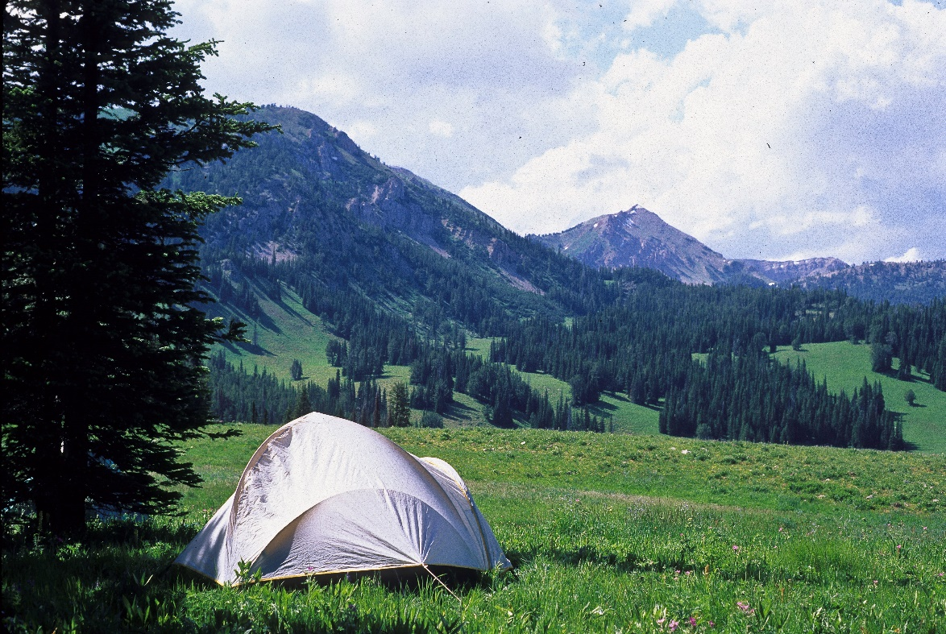
Teepee Basin in proposed Cabin Creek addition to Lee Metcalf Wilderness. Photo by George Wuerthner.
