Ponderosa pine in King Mountain proposed wilderness. Photo by George Wuerthner.

NAME: KING MOUNTAIN PROPOSED WILDERNESS

SIZE: 10,502 Acres

LOCATION: Ashland Ranger District northeast of Birney, Montana.

ELEVATION: Minimum Elevation 3,152 ft. Maximum Elevation 4,198 ft.

FS POLYGON Ashland 95

ATTRIBUTES: The King Mountain proposed wilderness lies just west and south of King Mountain. It is largely unroaded and undeveloped. Twelve miles of grazing allotment fences dissect the area and there are scattered water developments used for livestock production. Several motorized routes used for livestock management exist. The area has a generally natural appearance but can appear modified around pipelines, roads, trails and developments.

Historically, a number of drainages with headwaters along the flanks of King Mountain divide provided access routes from O’Dell creek to Otter Creek. Prehistoric campsites, stone circles and stone quarries are found along these routes with overlooks provided by the divide.

PLANT COVER: Mostly Northern Great Plains grassland/sage with about 15% of the area covered in ponderosa pine.

WILDIFE: Elk security habitat: 7,161 acres and Sage Grouse general habitat: 5,153 acres

DRAINAGES WITHIN THE PROPOSED WILDERNESS: Brian Creek, King Creek, O'Dell Creek

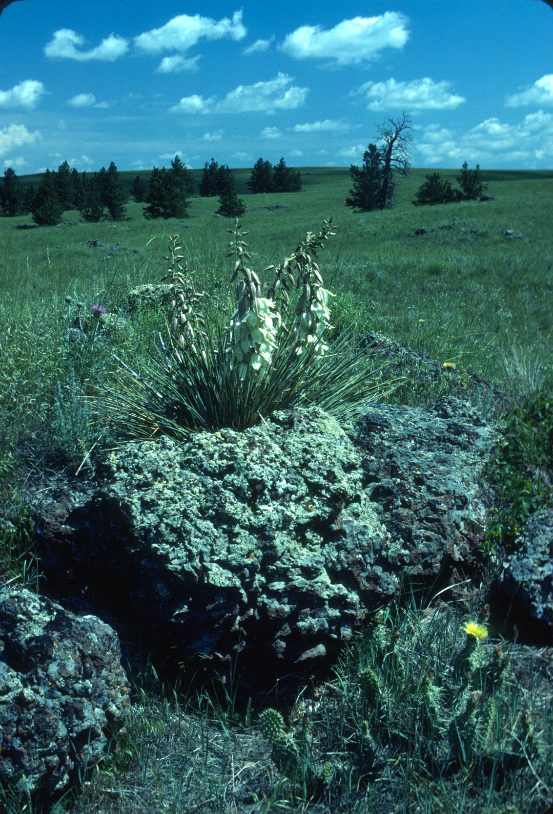

Yucca in bloom. Photo by George Wuerthner

