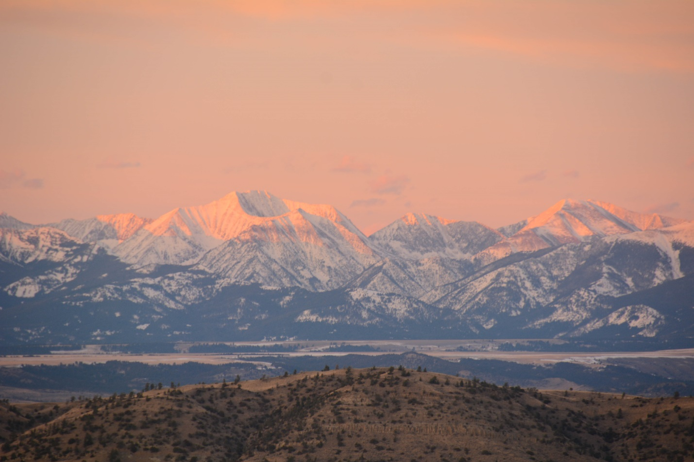
Sunset on the Crazy Mountains. Photo by George Wuerthner.
NAME: CRAZY MOUNTAINS PROPOSED WILDERNESS
SIZE: 90,640 acres
ELEVATION: Minimum Elevation 6,068 ft. Maximum Elevation 11,214 feet.
LOCATION: The Crazy Mountains are located north west of Big Timber, Montana and east of Clyde Park, Montana.
FS POLYGONS: CRAZIES 36, CRAZIES 37, AND CRAZIES 38
ATTRIBUTES: The Crazy Mountains are a dramatic glaciated mountain range that rises more than 7000 feet above the surrounding plains—equal to the elevational gain of the Tetons above Jackson Hole. Crazy Peak at 11,214 feet Is the highest summit in the range. The range is volcanic in origins and has numerous “dikes” radiating out from the central peaks. There are more than 30 alpine lakes. At least one relict glacier, Grasshopper Glacier, exists in the range. 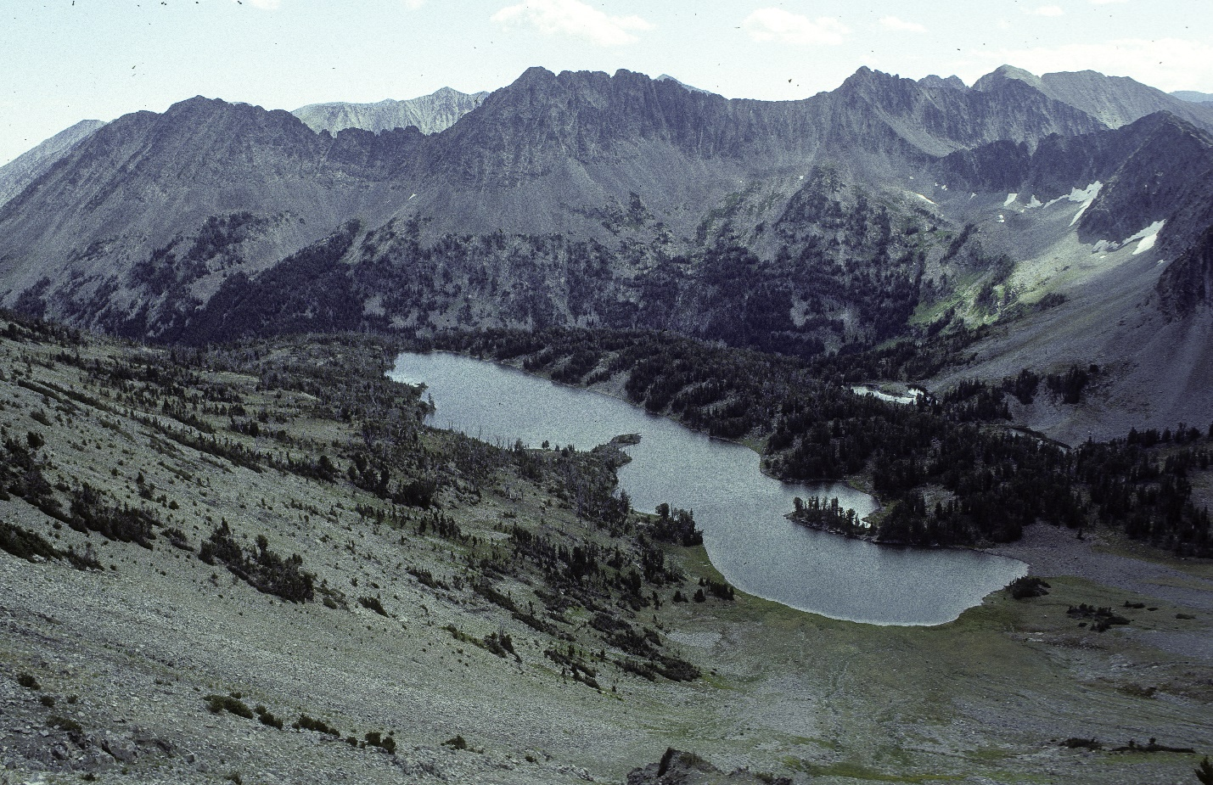
One of the many alpine lakes found in the Crazy Mountains. Photo by George Wuerthner.
This area goes north to Sweetgrass Creek and includes most of the high peaks in the southern portion of the range, including trails like Cottonwood Lake on the west side and Twin Lakes at the headwaters of Big Timber Creek on the east side. The central area includes the headwaters of the South Fork Shields, American Creek, headwaters of Sweetgrass Creek, while the Northern Crazies consists of rolling grassy hills to the north of the South Fork of the Shields and includes Smith Creek headwaters.
Parts of the Crazy Mountains were used by members of the Crow Tribe for fasting and vision guests, and the ranges has spiritual significant to the tribe.
The biggest obstacle for wilderness designation is the private checkerboard ownership of land, a legacy of railroad giveaways from the late 1800s. However, it should be noted that in previous wilderness bills, which included the Crazy Mountains, Congress directed the FS to acquire these private lands so that wilderness designation of the range would be possible.
Note that there is additional roadless lands on the Helena-Lewis and Clark National Forests that are proposed for wilderness as well, making it possible to protect more than 135,000 acres as wilderness.
PLANT COMMUNITIES: 15% lodgepole pine, 15% Douglas fir, 10% subalpine fir and some aspen.
WILDLIFE: Black bear, mountain goat, mule deer, whitetail deer, elk, and wolverine. Yellowstone Cutthroat Trout known to occur within 45 miles of stream.
DRAINAGES IN THE PROPOSED WILDERNESS: Big Timber Creek, Sweetgrass Creek, Cottonwood Creek, Smith Creek, South Fork Shields, Upper American Creek.

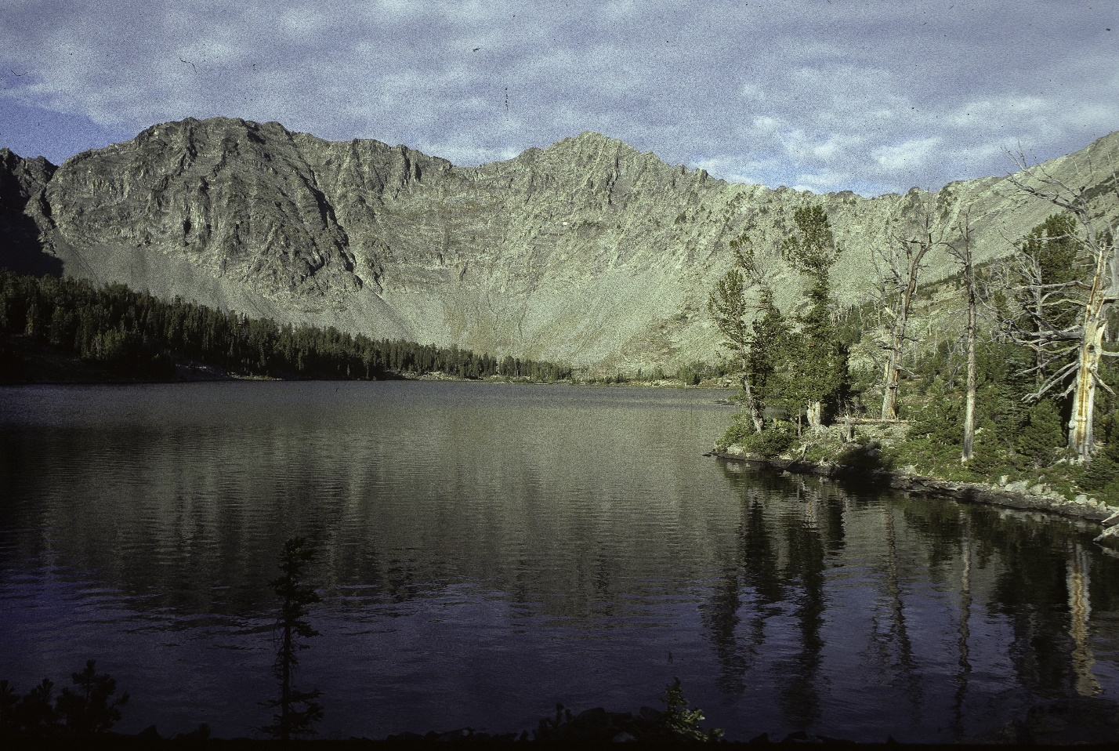
Campfire Lake Crazy Mountains Proposed Wilderness. Photo by George Wuerthner.
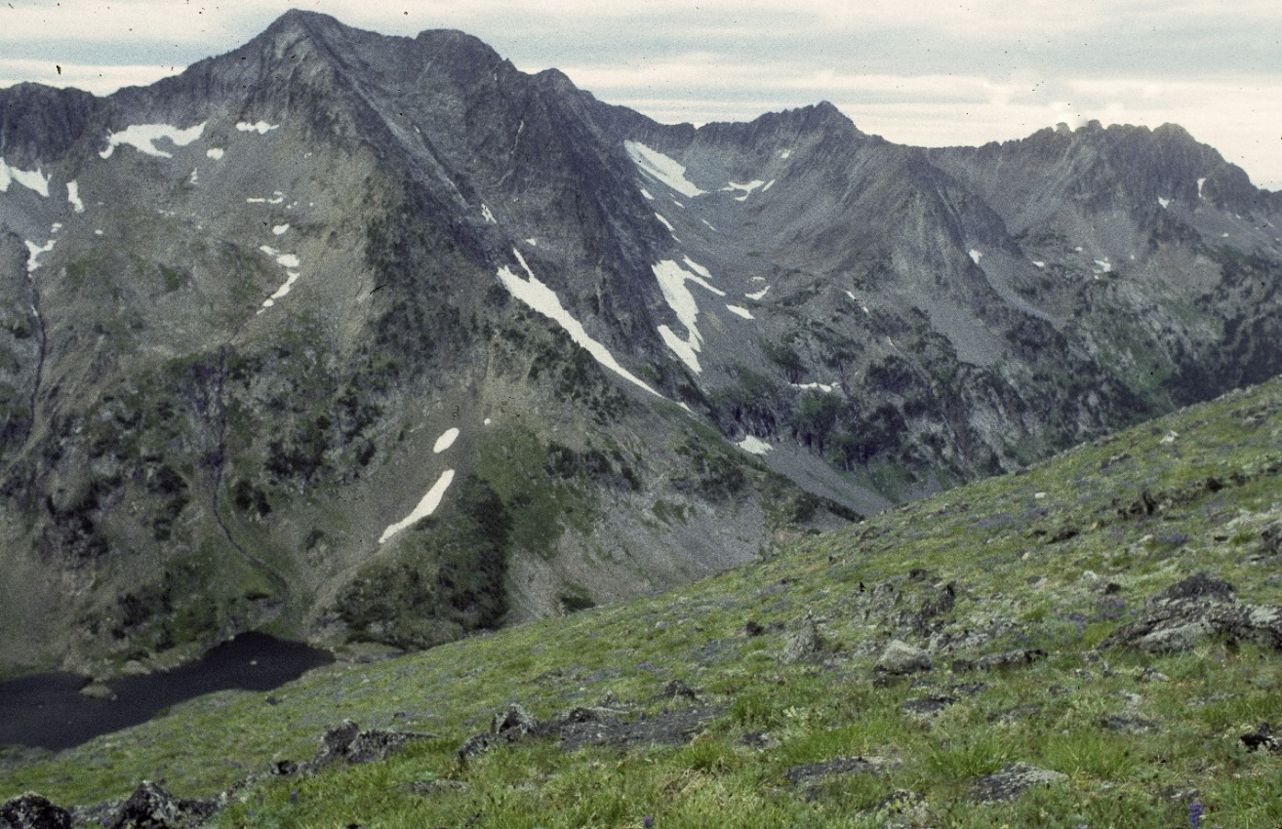
Headwaters of Sweetgrass Creek. Crazy Mountains Proposed Wilderness. Photo by George Wuerthner
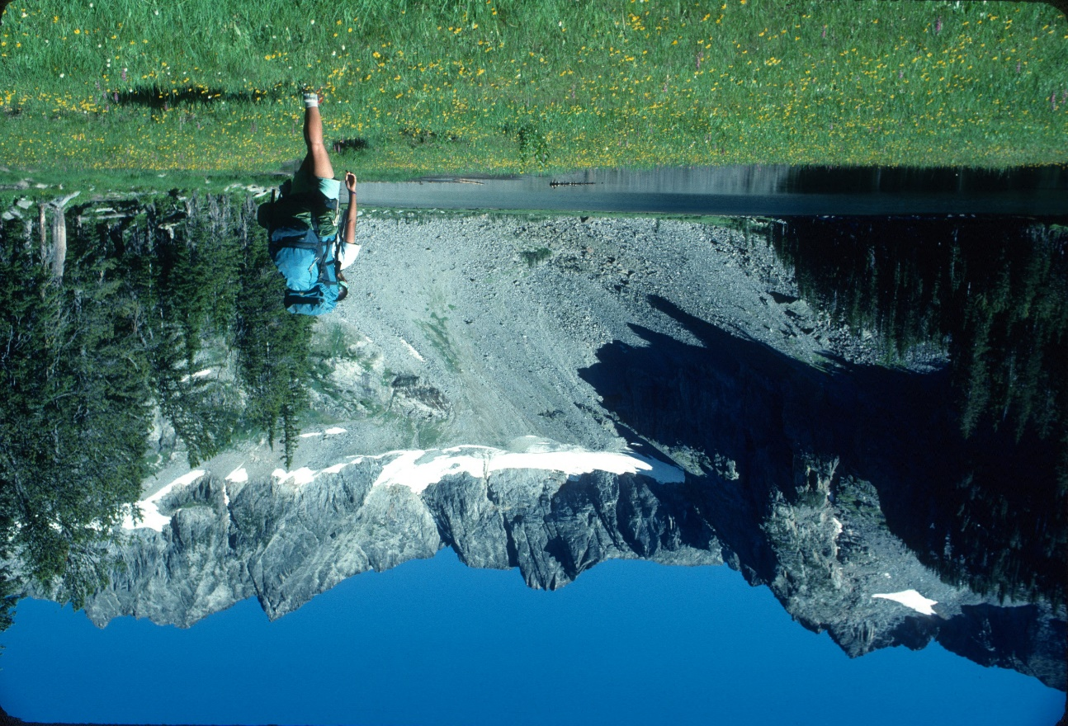.Backpacker at Twin Lakes, Crazy Mountains. Photo by George Wuerthner
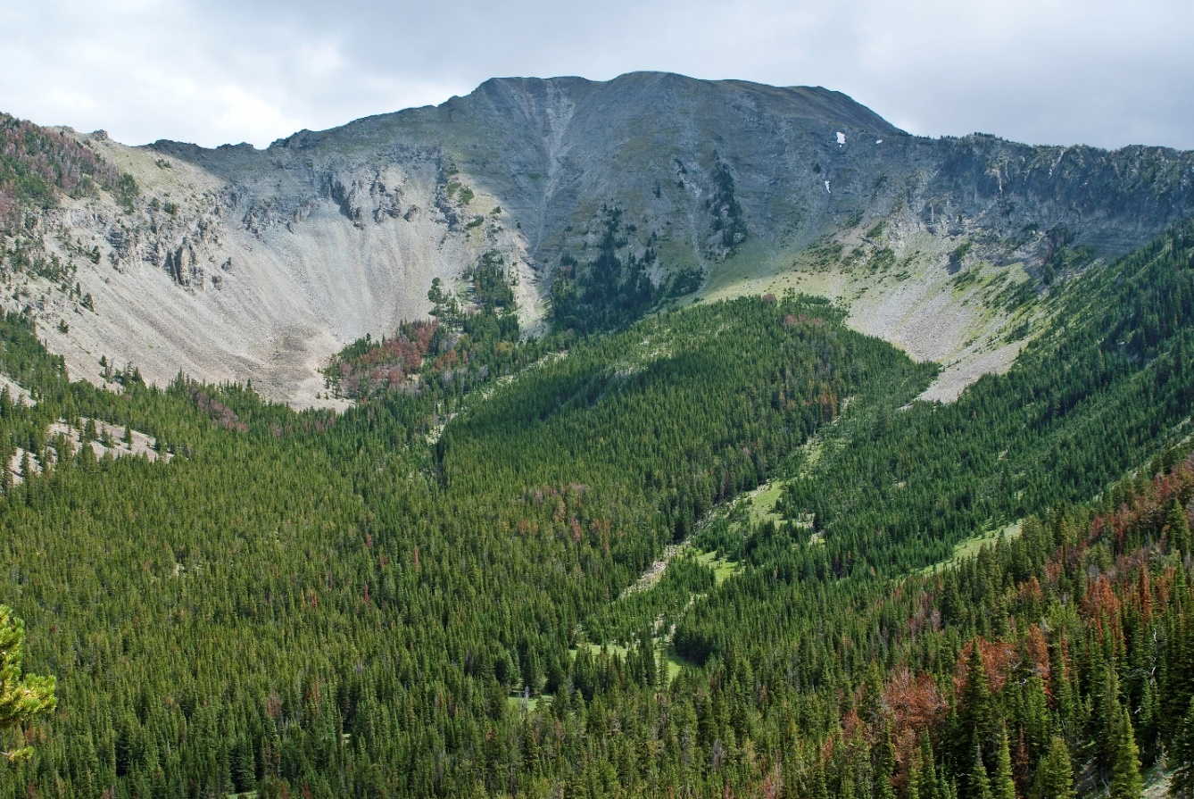
Sunset Peak Crazy Mountains Proposed Wilderness. Photo by George Wuerthner.
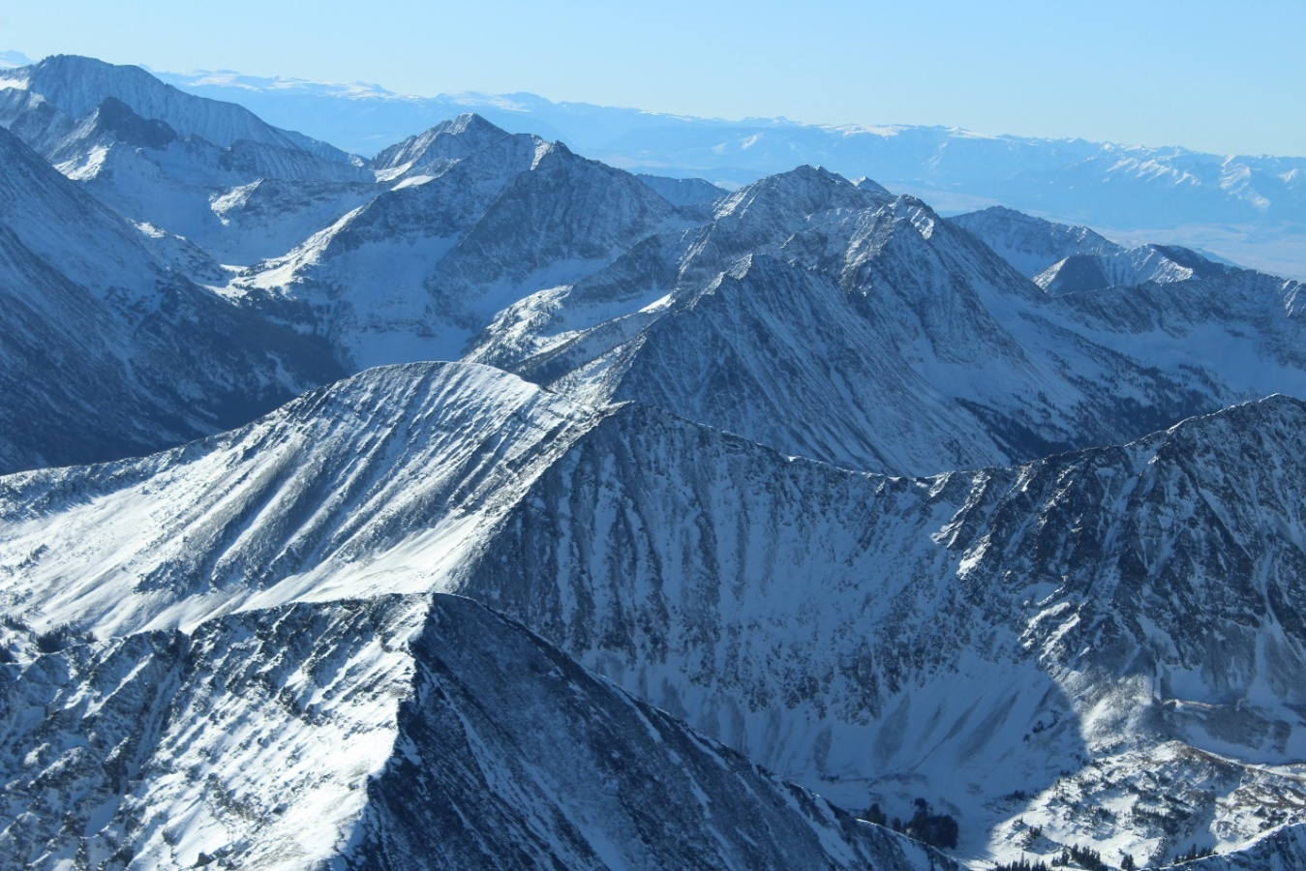
Crazy Mountains from air. Photo by Glenn Monahan.
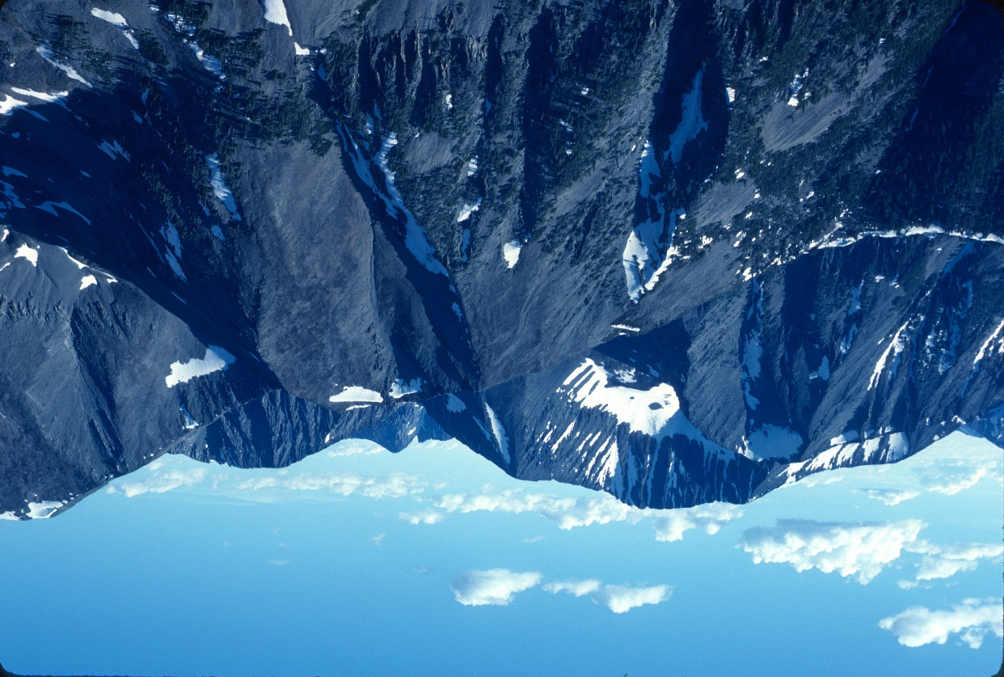
Iddings Peak, Crazy Mountains. Photo by George Wuerthner

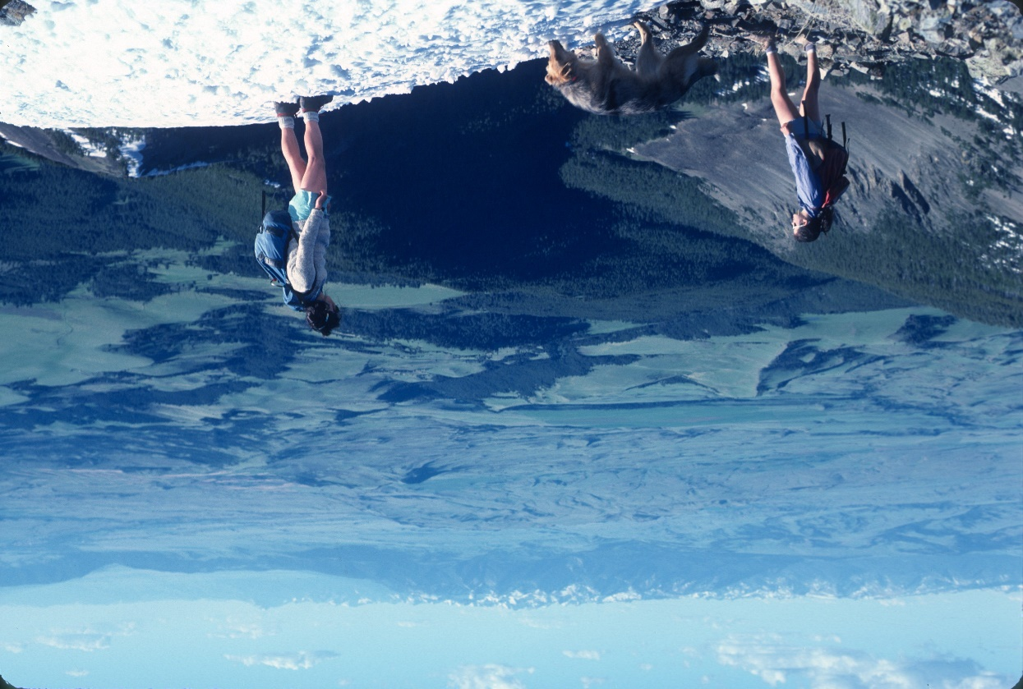
Hikers on Fairview Peak, Crazy Mts. Photo by George Wuerthner
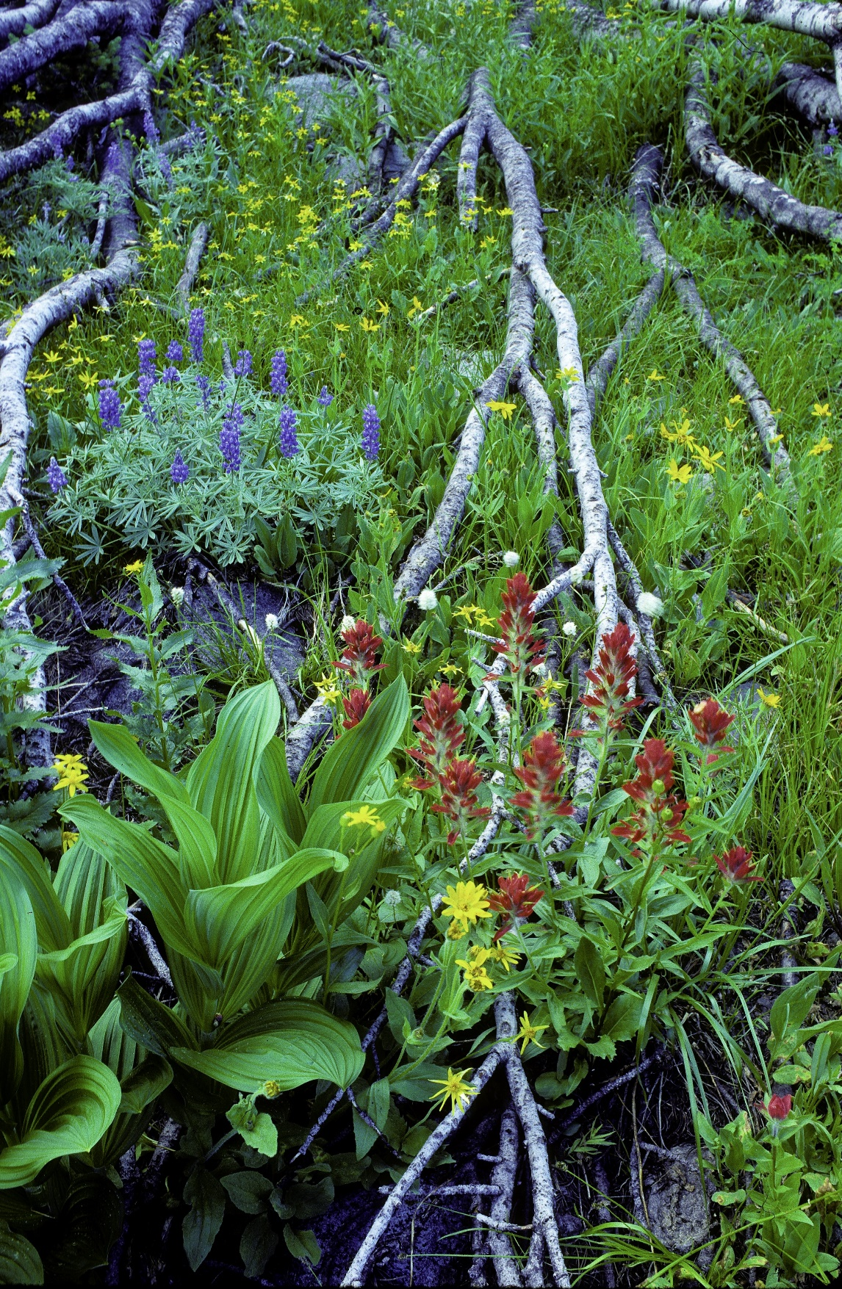
Wildflowers by Twin Lakes. Crazy Mountains Proposed Wilderness. Photo by George Wuerthner.

