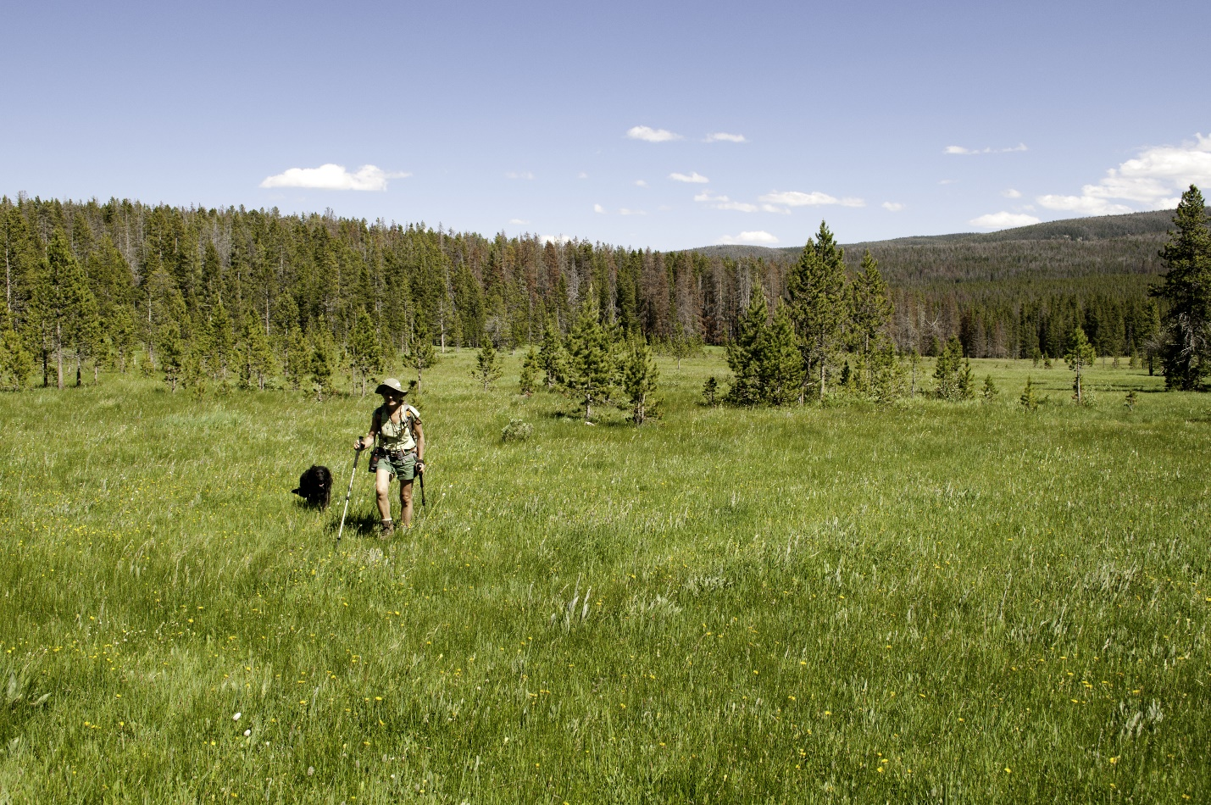
Hiker in meadow of Cowboy’s Heaven. Photo by George Wuerthner

NAME: COWBOYS HEAVEN ADDITION TO LEE METCALF WILDERNESS
SIZE:17,588 acres
ELEVATION: Minimum Elevation 5,861 ft. Maximum Elevation 8,843 ft.
FS POLYGON: Madison 25
ATTRIBUTES: The Cowboy Heavens addition the Lee Metcalf Wilderness has a foothills feel with rolling timber, many meadows, and perennial streams. Cowboys Heaven lies between the Bear Trap Canyon unit of Lee Metcalf Wilderness and the Spanish Peaks unit of the wilderness. It receives heavy hunting use during big game season. A portion of this area is recommended wilderness on the Beaverhead-Deerlodge National Forest. There are five trails crossing the area.
PLANT COMMUNITIES: 40% lodgepole pine, 30% Douglas fir, 10% Englemann spruce, and 5% whitebark pine.
WILDLIFE: Elk, mule deer, black bear, and moose. Westslope Cutthroat Trout known to occur within 16 miles of stream.
DRAINAGES IN THE PROPOSED WILDERNESS: Cherry Creek, Bear Trap Creek, and South Fork Spanish Creek.
